Strategic Estate Framework Contents

1. INTRODUCTION 2
2. VISION 3
2.2. The challenge 3
2.3. Foundations 4
2.3.1. Reshaping our Estate Principles 5
2.3.2. Estates Committee Decision-Making Guidelines 6
2.3.3. Sequencing Indicators 6
2.4. Engagement Insights 6
3. DESIGN PHILOSOPHY 8
3.1 A conceptual approach 8
3.2 A change in thinking 10
3.3 Applying these concepts 12
3.4 Connecting people within our sites 13
3.5. Connecting people inside our buildings 14
3.6. Connecting people across our estate 15
3.6.1. The three zones 16
3.6.2. Golden web 17
3.6.3. Hub spaces 17
3.6.4. Forum spaces 17
3.6.5. Heritage trail 17
3.6.6. Commercialisation 18
3.6.7. Wayfinding 18
4. CONCEPT TO REALITY 20
4.2 Entopia Building 20
4.3 Stirling Building 22
4.4 Roger Needham Building 25
4.5 School of Biological Sciences – Future Estate Needs 28
5. PRINCIPAL PROGRAMMES 32
5.2 Downing Site, New Museums Site and part of Old Addenbrooke’s Site 32
5.3 Technology at Cambridge West 34
5.4 Arts, Humanities, Social Sciences and University Library 35
5.5 Cambridge Biomedical Campus 36
5.6 Supporting Cultural Institutions 38
5.7 Exit of Mill Lane North 38
6. ENABLING STRATEGIES 40
6.2 Environmental Infrastructure 40
6.3 Equality, Diversity and Inclusion 41
6.4 Civic Framework 41
7. Appendices 43
7.1 Video: This is our place we hold the keys 43
7.2 Video: Enhancing Staff and Student Wellbeing 43
7.3 Video: Improving connectivity across the estate 43
7.4 Video: Sustainable and fit for purpose facilities 44
7.5 Video: Effective multipurpose spaces 44
7.5 Video: Effective data connectivity 44
7.6 Video: Effective sites to better connect staff and students 44
7.7 Video: Efficient areas for collaboration 45
7.8 Video: Effective data connectivity 45
7.9 Video: Enabling efficient movement across the estate 45
7.10 Video: Improving access across the estate 46
7.11 Video: Designing effective spaces 46
7.12 Video: Past meets place across the estate 46

INTRODUCTION
For over 800 years, the University of Cambridge has contributed many of the ideas that shape our world.
History has been made – and written – in its buildings, halls, libraries, lecture rooms and laboratories. Our duty today is to ensure that the University can continue to maintain and develop the physical spaces that will allow it to deliver world-leading education and ground-breaking discoveries.
We need an estate that enables collaboration, connecting people across different disciplines. We need an estate that is efficient and sustainable. We need a high-quality built environment that allows smarter use of space and reduces running costs, allowing us to reinvest available resources in research and teaching.
This Strategic Estate Framework has been crafted in collaboration with the University community. It outlines some of the opportunities that will allow Cambridge to continue making ground-breaking discoveries for generations to come.
Introduction written by Professor Deborah Prentice, the Vice Chancellor of the University of Cambridge

VISION
The Strategic Estate Framework sets out a design philosophy and series of concepts that have been developed through ongoing and continuous meetings with our community.
The overwhelming theme identified through engagement is the need to create spaces that better connect our people. Based on this feedback, a long-term vision for the estate has been developed from these discussions that underpins a new design philosophy for the University’s estate.
The estate vision:
To support the University’s academic mission by developing facilities and links that better connect people (a) across our estate, (b) within our sites, (c) inside our buildings.
By delivering higher quality and more welcoming places that encourage collaboration and that promotes an inter-connected community of scholars, we will improve academic outcomes in a way that also uses our estate more intensively.
This will create vibrant spaces that will improve both the staff and student experience and their wellbeing in a way that is more enjoyable and supportive for all our people, as well as being more biodiverse and sustainable, all at a lower cost, enabling reinvestment back into research and teaching.

2.2. The challenge
The current estate is not operationally, financially, or environmentally sustainable to support the academic mission.
We need a more effective estate
Around 25% of the estate is considered in a poor condition (grade C or less) and a further 25% might not be considered fit-for-purpose for a world-leading University.
We need a more efficient estate
The University's estate is 23% larger per head than any other University. As a result, our fixed estate overheads are higher than other Universities; therefore, we will be less cost competitive, tying up money that could be invested directly into more productive research and teaching.
We need a more environmentally sustainable estate
The University emits double the carbon emissions per head than the Russell Group average. Our larger estate will be more expensive per head to decarbonise than most other Universities.
Estate statistics:
- 25% of the estate is in a poor or very poor condition, with 50% no longer fit-for-purpose for a modern university.

- The University emits double the amount of carbon per head than the average across the Russell Group Universities.

- In 2022/23, the estate used:
  - 144,071,965 kWh of electricity, equivalent to powering 53,360 UK households
  - 104,420,613 kWh of gas, equivalent to heating 9,080 homes
  - 6,821,764 kWh of steam, equivalent to heating another 600 homes

- In a 2018 study (AECOM Climate Change Risk Report), 28 buildings were identified as particularly susceptible to overheating. The following spaces have the highest percentages of related assets found with the heightened vulnerability to extreme heat events:
  - Examinations 14%
  - Research delivery 10%
  - Teaching and learning 11%

- In the same study, 81 building assets were found to have heightened vulnerability to flooding. The museums and libraries function have the highest percentage of more vulnerable assets to flooding, which is due to the presence of basements and the constraints on adaptive capacity due to the status of some as heritage assets.
- £140m+ spent each year to operate and maintain the estate.

- With 333 operational buildings providing over 740,000 sqm of space, the operational estate is the size of three Empire State Buildings. The size of the estate includes:
  - 333 Operational buildings
  - 46 Listed buildings
  - 42 Derelict non-operational spaces

- 34% of School allocated space is workspace / office

- 5% of School allocated space is shared social space

- £4,070 average cost per head per year

- 23% more space per head than any other university, with 50% more space than the average Russell Group University

- The estate supports 12,000 staff and 24,000 students – an average of around 20 sqm per person
Please note this data is based on the University estate only, not including College areas. Data sources include MiCAD, HESA, HR, Academic and Financial Planning and Analysis, Estates Finance, Environmental Sustainability Team, OPEX, Environmental Sustainability Report 2022/23.

2.3. Foundations
The University Council agreed a set of six estate principles in 2024 that form the foundation for any change in the estate. All projects must conform to these principles.
The Estates Committee agreed a set of decision-making guidelines to help teams understand how the Committee will review each programme and project to meet the design principles.
At a time of constrained funding, there will always be more demand for change than availability of funds. The Reshaping Our Estate Programme Board has developed a series of sequencing indicators as a tool to help decision-makers prioritise competing projects.
As part of the University’s design guide, a design philosophy will support new projects and programmes which have been approved. The design philosophy sets out a new way of thinking that will support how to design buildings in a way that meets the estate vison - connecting people across the estate, within the sites and inside the buildings. The underlying approach is to move away from standalone buildings that do not interact with surrounding buildings, the landscaping and infrastructure around them.

2.3.1. Reshaping our Estate Principles
Reshaping our Estate will allow us to create an estate that is more effective, more efficient, more environmentally sustainable, and fit-for-purpose, which celebrates the past and looks to the future.
The Reshaping our Estate Principles are as follows:
1. Create high quality spaces that support staff and students to do their best work
Our estate should create a positive and productive working and learning environment for our staff and students and support excellence in teaching and research, and our public-facing activities.
2. Develop a smaller estate with more shared spaces
We should reduce the size of our estate and encourage space sharing to make better use of our existing spaces, avoid unnecessary costs and reduce our carbon footprint. We should consider opportunities to monetise parts of our estate which are not needed for teaching, research, public-facing or professional services space.
3. Consider how to make the most of existing spaces before building new ones
Wherever possible, we should meet our space needs using existing buildings rather than building new ones where financially and environmentally sound. This will help us to manage our estate in a more affordable way, while minimising the environmental costs of construction. We should make sure that new buildings meet recognised sustainable building standards, and that any development of our estate delivers a net gain in biodiversity.
4. Support teams across the University to adopt new ways of working
Our physical estate should enable the University to adopt flexible working practices and allow staff to work in spaces that support their style and meet their needs.
5. Develop a financially and environmentally sustainable estate
We should be seeking all opportunities to reduce carbon emissions in our estate as part of the University’s aspirations for a zero-carbon future. We should look for opportunities to mitigate the environmental costs of managing our estate, for example by introducing more environmentally sustainable practices with regards to energy use or waste management. The operation of our estate must be financially sustainable, and there must be full transparency on how much it costs to manage our estate.
6. Protect and promote our built and cultural heritage
Our estate strategy should protect our architectural and cultural heritage and develop high-quality public spaces for staff, students, residents and visitors to enjoy.

2.3.2. Estates Committee Decision-Making Guidelines
The Estates Committee Decision-Making Guidelines have been produced to provide guidance and insight into how the Estates Committee will consider future projects.
These decision-making guidelines are underpinned by the Reshaping Our Estate Principles and support the overall ambition to create an estate that is more efficient, more effective, more environmentally sustainable, and fit-for-purpose.
The decision-making guidelines focus on the attributes of a single project and are intended to give an insight into how Estates Committee will consider individual business cases.
It is not a checklist, and projects are not expected to conform to each and every guideline. It is also a living document and guidelines will be changed, adapted and clarified over the coming years as projects are considered.
Click to access the Estates Committee Decision-Making Guidelines.

Sequencing Indicators
The Sequencing Indicators were developed by the Reshaping Our Estate Programme Board.
They provide a tool for decision-makers to help make decisions where choices need to be made between different projects and programmes when there are constrained financial resources.
They are a framework by which discussions can be structured and are not a methodology or algorithm by which every project can or should be measured.
Click to access the Sequencing Indicators.

2.4. Engagement Insights
Before any opportunities for the estate could be created, we engaged with the University community to understand the different School’s academic visions and wider University ambitions.
Over 150 interviews and 14 workshops were conducted with the Schools and Non-School Institutions (NSIs), as well as focus groups with both undergraduates and postgraduate students, which gathered insights on how individuals and teams across the University feel about the current estate and what the future might hold.
From this work, over 3,000 interview comments were analysed and categorised into themes.
Datasets were analysed to look at the type of spaces available, the demand for those spaces and the quality of the accommodation.
To summarise, staff shared the following insights:
- The quality of spaces are generally poor and not fit-for-purpose.
- The existing estate restricts academic growth.
- The space to support collaboration and interdisciplinarity both within and across the Schools is critical and yet unavailable.
- A variety of different spaces are required both for the ability to work quietly and to ensure that spaces are fully inclusive and accessible.

To summarise, students shared the following insights:
- The student experience could be improved with a greater sense of belonging and a desire to feel more a part of the cultural heritage of the University.
- There should be a greater focus on delivering welcoming work, social and collaborative spaces that are fully accessible and inclusive, and which would improve student wellbeing.
- Sustainability and climate change must be at the heart of what we do, with a more welcoming biodiverse landscape that would promote local ecology and pride in where we live and study.

DESIGN PHILOSOPHY

3.1 A conceptual approach
This section explains the concepts and design philosophy that evolved through engagement with the University community.
These concepts will deliver our vision – developing facilities that better connect people across our estate, within our sites and inside our buildings, outlining opportunities for the future estate.
Connecting people across our estate
Considering every building across the estate together, the University should be better connected between the three main site areas: Cambridge West, Centre and South, interwoven with the Colleges. The entirety being approximately 4.5 miles across our entire estate, around a 25 minutes cycle ride.
Our community said the experience of travelling between sites could be drastically improved. Working with local authorities we want to review key transport links, pathways and cycle paths between our sites and buildings and provide much needed improvements to signage and lighting, as well as make biodiversity enhancements where possible.
Many people have concerns about how unwelcoming and unfriendly each site can be, which further discourages travel between sites. Visits to other sites and buildings are often challenging due to protected access to buildings with no places to sit and work without a formal invite.
The aim is to connect our community across our estate in safe, accessible, affordable and sustainable ways that encourage people to visit different University sites and facilities, whether they are a student, a member of staff, or a visitor.
Our design philosophy is a journey that connects our people to re-imagine the world class places we deserve. It is continuously evolving and themed to the needs our community have identified. This framework presents a series of opportunities that, over time, will deliver an effective, efficient and sustainable estate for our community.
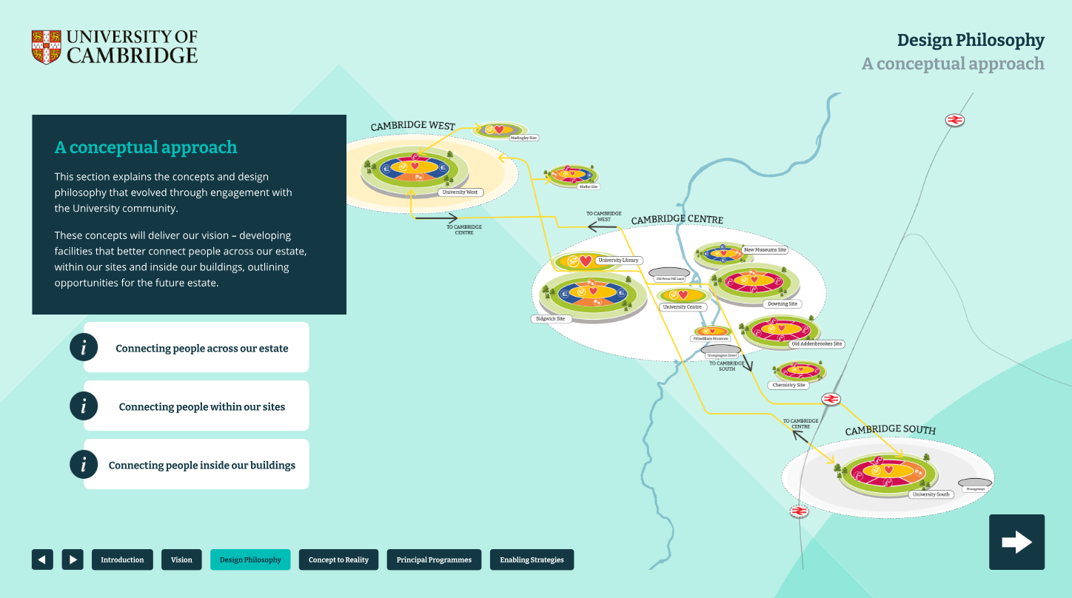
Figure 1. A visual which showcases a map of Cambridge, highlighting three circular zones of Cambridge West, Cambridge Centre and Cambridge South and how they connect together through smaller circular discs that represent each of the University’s sites including University West, Sidgwick Site, New Museums Site, Downing Site, Old Addenbrooke’s Site, Chemistry Site, and University South. Within each site disc, there are different colours and icons to illustrate the different types of spaces including social spaces, education spaces, museums and libraries, identity spaces.
Connecting people within our sites
Each of our sites should showcase our world-renowned University status, offering the best opportunity to learn and collaborate between disciplines. Our engagement found that many people feel our sites are not attractive destinations – whether that is because of the unwelcoming feel across locations, or the poor-quality facilities they provide.
Our community told us that unless attending a pre-booked meeting, there is no purpose to visiting another location. Many told us that most sites do not have a welcoming centre or place to sit down and work. Our students told us that there are few places to work between lectures with many libraries accessible only by the relevant department.
We propose to develop attractive spaces, both indoor and outdoor, that enable people to work within a choice of environments, to feel connected with peers, and provide areas that support and enhance wellbeing. Providing a range of workplace settings that suit different preferences and requirements will enable higher quality research. Creating social and collaborative spaces that seamlessly connect through an inviting biodiverse landscape will support greater inclusivity and accessibility.
All spaces across the site will feel like an extension to another, with easily accessible inviting places to work, pause and reflect. Spaces will celebrate the local discipline specialism whilst promoting interdisciplinary work. We expect that the higher quality spaces will be used more intensively, reducing excess underused space and lowering cost by default.
Connecting people inside our buildings
Currently our buildings generally operate on an individual single department basis, with each building having similar elements but on a smaller scale, with lower quality and duplicated support facilities such as social areas.
Existing post-graduate, PhD and post-doctoral research spaces in many buildings are of poor quality and significantly underused. Engagement with our post-graduate community has indicated that loneliness is a significant concern.
There is an opportunity for our buildings to work together to create more welcoming, higher quality facilities with a range of workplace settings to suit different needs.
Our community highlighted that retaining faculty, departmental or division identity is fundamental; ensuring a ‘home space’ for staff and students is provided. Departmental or faculty ‘identity spaces’ must be retained but enhanced and celebrated with a clear front door.
To enhance the connections across our sites and within our buildings, it is important that the ground floors should be permeable and welcoming to all. Ground floors should feel connected across each building, providing facilities that will be heavily used by many people, for example teaching, seminar, meeting, social, collaboration, library and exhibition/ showcase spaces.
Whilst the ground floors create the vibrancy, the upper floors will become dedicated to department identity space and research specific environments. These home spaces will provide specialist areas, focused collaborative settings, flexible research neighbourhoods and private spaces, available for meetings and individual quiet working.

3.2 A change in thinking
Engagement with our University community clearly communicated a desire for change, which offers the opportunity to think differently about how our estate can work. Rather than siloed space within each building that provides every type of space for one department which is small scale, generally of poor quality and only available for its users, we have the opportunity to look at the whole site cohesively. Whilst ensuring every department has its home and front door, we can incorporate some facilities and types of spaces, freeing space for resources that do not currently exist or enable growth as well as providing higher quality spaces both inside and outside our buildings.
At the heart of each site, is the ‘forum’ which will be available to all University staff and students for extended opening hours – another key request outlined in engagement meetings. The forum will provide an inclusive and accessible choice of where and when to work, be that quiet individual study, or collaborative research clusters depending on personal preference and need. The forum will provide a space that showcases the specialism of the location, displaying previous breakthrough discoveries and potential future innovations. The forum will signify the welcome and vibrancy of our community. From these forum spaces, teaching and library spaces will be clearly visible and accessible.

Around these spaces, research focused neighbourhoods will be created. Whether single or cross disciplinary, all spaces will provide the right place to work, providing a choice of environments and places to be between lectures and meetings, creating efficient utilisation across the location.
Our community suggested that, in this modern age of research, there is the need to be able to adapt spaces at speed and respond to changing priorities and evolving needs. Creating connected spaces with multiple uses allows us to be flexible and adaptable whilst also efficient. For example, seminar rooms can become quiet places to work and revise during exam periods, when seminars are not taking place or during lunchtimes when library spaces are busy. Multiuse spaces will provide opportunities to expand, grow or change where inter-disciplinary research spaces are required to deliver particular new cross disciplinary research themes.

Each location will offer a range of accessible and inclusive spaces, including green external spaces which collectively support collaboration, wellbeing and nature. Hard and green infrastructure will be planned and delivered through a site-based approach to ensure that across and between sites there is a coordinated and efficient approach to providing the utilities, services and operations needed to support the delivery of our academic activities.

The different types of spaces that will sit within a site:

- Forum – At the heart of each site, the ‘forum’, is a space available to all University staff and students with extended opening hours. A place that will feel welcome and where you can access specialist facilities and collaborate in ways that offer new learning and research opportunities. The forum will showcase the location as a centre of excellence for the discipline across the world.

- Social and collaborative spaces – A variety of inclusive spaces open to all for use in-between lectures or to meet with colleagues, encouraging collaboration and community connections across the University. The social space will be visible and vibrant with diverse settings to work and relax.

- Education spaces - Dedicated and flexible education spaces for teaching, learning and exams. The education space will be visible, varied in size, digitally enabled and multi-purpose to create stimulating environments that can be used throughout the day, term and year.

- Unique and specialist spaces – Specialist spaces for multi-disciplinary use. Unique spaces will showcase the location excellence, they will not be duplicated across each location creating a destination within the estate ensuring both effective and efficient spaces.

- Museums and Libraries – Multi-use spaces that showcase our heritage and learning environments. Our libraries and museums are renowned destinations welcoming both the University community and visitors. They will be accessible, visible and provide flexible study and working environments to support and enhance our academic brilliance.

- Identity spaces – Identity spaces, promoting ‘home’ spaces for departments with specialist facilities. These spaces are flexible and adaptable to maintain and enhance the discipline identity whilst providing space for new research themes to evolve and thrive.

- Postgraduate, PhD and Postdoc spaces – These areas will create flexible neighbourhoods with work, social and collaboration space for postgraduates, postdocs and PhDs, which will be themed to the identity of the relevant academic discipline. This space will offer a range of settings to encourage people to support each other, collaborate across other disciplines, whilst also providing quiet places for focused study.
- Green Infrastructure – A network of interconnected, biodiverse spaces that help connect buildings and sites across our estate, supporting wellbeing and nature. Green infrastructure provides a resource for outdoor learning, relaxation and collaboration. Investment in green infrastructure helps to make the estate more climate resilient by providing crucial environmental services such as rainwater soakaways and shading to reduce overheating within our buildings.

- Catering – A variety of food and beverages to be easily available across the site is proven to support people as they work and collaborate.

- Transport – Access to safe, accessible and sustainable transport options that are reliable and affordable is essential for connecting staff, students and visitors across our estate. Investment in transport infrastructure underpins this and is a prerequisite for the future development of the University’s estate. Our transport provision will meet the University's goals of inclusivity and equity.

- Energy and water – Energy and water underpins everything we do as a University. We need infrastructure that ensures our energy and water supply is reliable, resilient and can flex to meet the future needs of our academic activities, whilst minimising our climate impact.

- Data – Ensuring access to data cabling, systems and data storage with associated cooling and power are considered as part of a university-wide strategy.
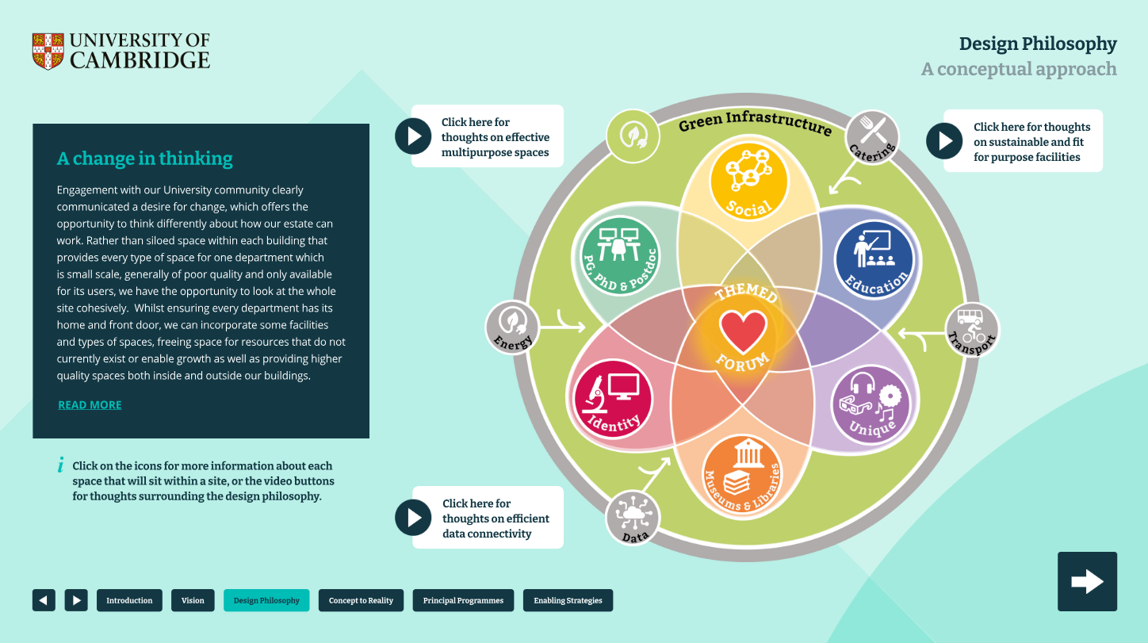
Figure 2. A colourful circle diagram which reflects the different types of spaces and operational infrastructure which underpins the design philosophy of the University’s estate. On the outer circle, there is a grey line which includes four icons that represent catering, transportation, data, energy. The inner circle is green, with an icon to represent green infrastructure. Within the inner circle is a flower diagram with six petals that each represents social spaces, education spaces, unique spaces, museums and libraries, identity spaces, and postgraduate, PhD and Postdoctoral spaces. Within the centre of the petal and overall diagram is a heart icon, representing themed forum spaces that is a key component to all the above spaces of the estate. This illustration encapsulates the design philosophy, showcasing how the different types of spaces and infrastructure work together to create a more efficient, effective and sustainable estate.

3.3 Applying these concepts
Our current sites are characterised by separate isolated buildings which generally focus on single departments, faculties, or divisions each with smaller scale facilities, in many cases only accessible for own users with protected swipe card access. Feedback from our community said that many of our buildings lack adequate social and collaborative space. This combined with around half of our estate being poor-quality or not fit-for-purpose, does not provide efficient value for money or effective spaces for the teaching and research of a world-leading University.
By re-thinking our sites, we can provide higher quality facilities that provide greater intensity of use in vibrant, diverse and inclusive environments, whilst promoting the identity of each School and its departments, faculties, or division. Security is important to protect both intellectual property as well as to ensure health and safety in hazardous environments. An improved balance between collaboration and the need for security is a key enabler.
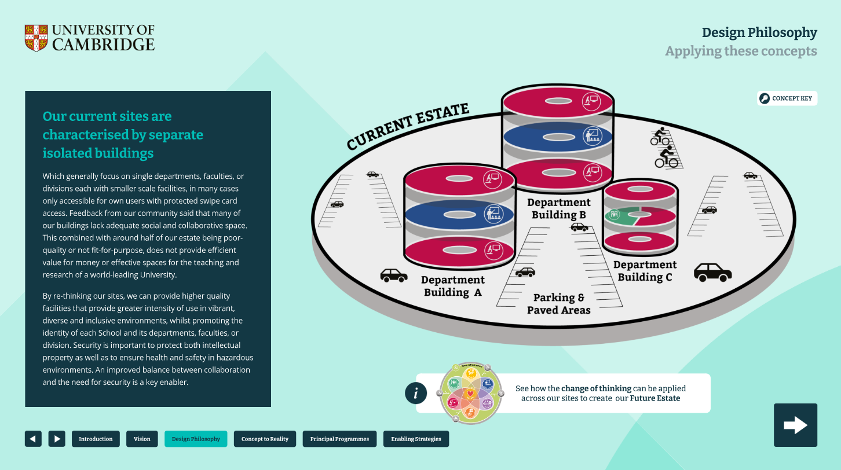
Figure 3. A grey disc illustration that depicts the current University estate. Within the disc is three siloed departmental buildings which are made up of three smaller stacked discs, each representing a mix of educational and identity spaces. Surrounding the three buildings are paved areas including parking for cars and bicycles. This illustration showcases how current sites are characterised by separate isolated buildings.

3.4 Connecting people within our sites
A conceptual approach to connecting people within our sites:

Increasing efficiency will allow us to create high-quality sites whilst reducing overall cost. As each building is changed, it will be decarbonised and improve the surrounding external realm, helping our estate to become more biodiverse and inclusive. This will lead to more effective spaces and generate cost savings, money that can be reinvested to further support the academic mission.
Each location will celebrate a specialism as a world-renowned centre of excellence for the local academic disciplines. It will become a destination that people enjoy and feel proud to be a part of which fully represents our community. Our buildings need to work together to ensure we have the right distribution of spaces to create a learning landscape that promotes and supports the academic future.
To re-use our estate effectively we can organise space in accordance with the need. Our site must promote simple access, wayfinding and legibility of entrances through an inviting and biodiverse public realm.
The forum will sit at the heart of the site, within one or more buildings, it will house the shared, collaborative specialist and digital facilities needed to support each site. The forum will have different attributes and will be themed to the specialism of the site with wayfinding providing straight forward access; it should feel like the site front door.
Each building on the site must provide open, welcoming and permeable ground floors, where possible, to house teaching, meeting, social or library space for all users across the site. These spaces will be accessible and visible with connections to the external realm encouraging use.
Entrances to each building must be welcoming, ground floor spaces must seamlessly blend within and between buildings. Each will provide flexible education and research spaces, with different places to meet and study offering users a choice of workspace environments across the site. Spaces between the buildings will provide external pockets of space to meet and relax. Creating an enjoyable journey between the buildings that will encourage use across different disciplines and promote community.
Buildings will host clear ‘identity’ spaces that enable departments, faculties or divisions to create their own front door and sense of home. These spaces will showcase disciplinary excellence.
Adjacent to the identity spaces will be research ‘neighbourhoods’ themed to the relevant departments. The design of these will allow for flexibility of use, whilst supporting the identity of individual departments. Spaces will offer the opportunity for interdisciplinary collaboration, pop-up research groups and individual quiet study, with close synergy to the department at a postgraduate, PhD or post-doctoral level.
This concept creates a framework for the development of each location, it is designed to be flexible and create common themes that allow each project to contribute towards the vision for high quality spaces that are fit-for-purpose and support the academic mission of the future.
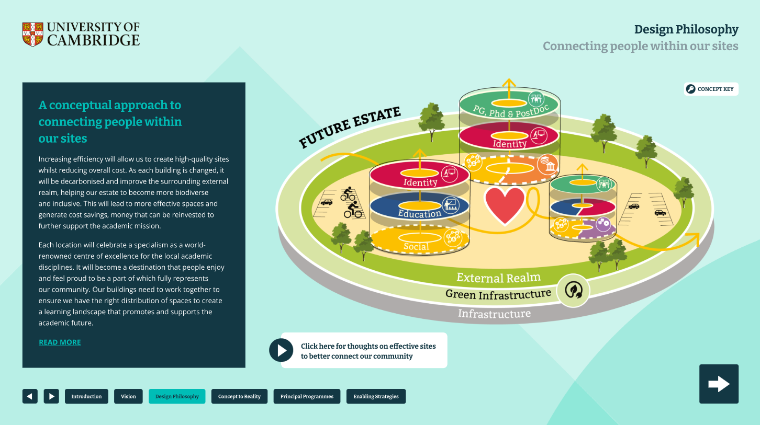
Figure 4. A colourful disc illustration that depicts the future University estate which includes a mix of different spaces and infrastructure that work together as outlined within the design philosophy. This includes showcasing three building examples made up of discs with an arrow pointing upwards to show the different types of spaces depending on floor level such as social space on the ground floor, with identity and dedicated research quieter spaces within the upper floor levels. The surrounding areas are green with tree icons and better wayfinding with a heart depicted within the centre of the disc to showcase the themed forum and central place that will naturally bring people together.

3.5. Connecting people inside our buildings
A conceptual approach to connecting people inside our buildings:

Our buildings will feel inviting and accessible with an open ground floor and vibrant entrance encouraging chance encounters with space to meet and chat. Crucially, each building will provide a variety of settings with different seating and working environments, offering diversity and choice. Each building design, area and brief must consider the site context and wider facilities available to offer the best diversity of site wide space, catering for many users across the site.
Flexible teaching and social spaces will ensure efficient utilisation throughout the day and year. Shared social space will vary in size and become consistent throughout the building, offering space to connect on all floors with smaller and dedicated spaces for focused discussion on the upper floors.
The entrance to the upper floors will be via a welcoming front door to each identity space for a department, division or faculty, creating a welcoming home that showcases their own disciplinary excellence, celebrating past discoveries, alumni, and looking to the future.
Spaces that sit on the higher floors will offer quieter spaces with continued variety and more focused research areas. From workspaces for research groups to cellular space for individual focus or small meetings, users will have the opportunity to work in places that support their need across the year.
Work settings will be diverse, from standard and adjustable height workstations, coffee tables, meeting booths, sofas and comfortable furniture to relax, in-built storage for books and belongings, and tea points to encourage a quick break and support wellbeing.
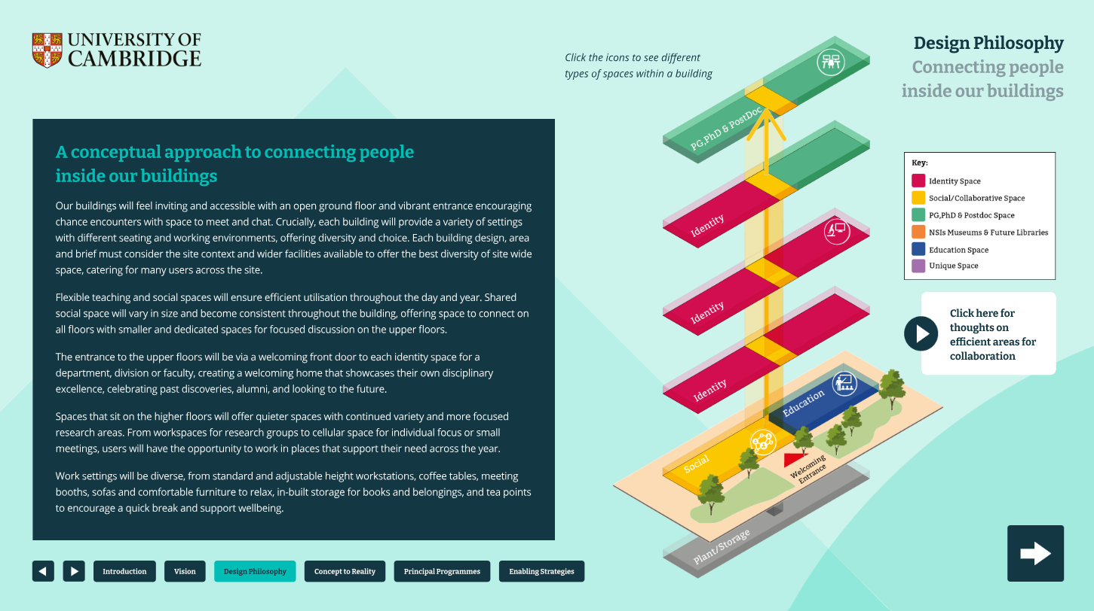
Figure 5. A building illustration made up of five stacked blocks showcasing how the design philosophy can be applied within a building setting, applying different spaces on a floor levels and how this supports the needs of staff, students and visitors. Each floor has an icon that represents a different type of space such as the group floor showcasing social and collaborative spaces, with quieter, dedicated spaces such as Postgraduate, PhD and Postdoc spaces placed on the upper floors.

3.6. Connecting people across our estate
A conceptual approach to connecting people across our estate:

Our design philosophy offers the opportunity to connect people across the entirety of our estate, providing a reason to travel between sites and connect with new people. It will remove duplication and poor-quality space across our estate and focus on the right activity in the right place.

It will create a series of internationally recognised destinations that will be busy, vibrant and showcase our research and achievements. Themed forum spaces at the heart of each location will act as an incentive for people to visit different sites to work, whether that is quietly, to collaborate or touchdown between lectures and meetings.

Within each of the three zones, the sites, and individual buildings, the concept seeks to design places that will draw together common academic disciplines, in a vibrant and inspiring manner. This will dramatically improve the way our sites and buildings are used, with students and staff able to work across a wide range of different, high-quality environments. A focus on improving biodiversity and our climate resilience will help to create environments that support health and wellbeing.
Over time, this design philosophy and the concepts that underpin our sites and buildings will deliver a more effective estate that supports the academic mission. This will intensify the use of space across the estate, freeing up poor-quality space in individual buildings, for other uses or commercial release, allowing reinvestment directly back into research and teaching. Our estate will feel connected, relevant and world-class.

Cambridgeshire and Peterborough Local Growth Plan
The Cambridgeshire and Peterborough Local Growth Plan outlines ambitions to triple the size of the region’s economy to £97.1bn by 2050. This aspiration builds upon the strong legacy of innovation and dynamic economic eco-system, with a focus on accelerating growth across key sectors including Life Sciences, Energy and Clean Technology, Advanced Manufacturing and Materials, Agri-Food and Technology, Digital Technologies, and Defence.
This Strategic Estate Framework aims to support these ambitions across the whole of the University estate by enabling an inter-connected world-class research, innovation, and collaboration spaces that drive sector growth and attract global investment.
“Realising the ambitious growth vision set out in this plan will require us all to work together. The University will bring its unique, globally leading capabilities to bear in close partnership with civic, academic and industry collaborators ensuring this region continues to thrive and set the pace for the world.” – Professor Deborah Prentice, Vice-Chancellor, University of Cambridge
Click to access the Local Growth Plan here.

3.6.1. The three zones
Cambridge University and its colleges sit at the heart of both the Cambridge academic community and wider economy. The University estate is largely focused within three zones: Cambridge West, Cambridge Centre, and Cambridge South. Better connectivity requires better signage and transport links between the sites and buildings, to encourage people to visit hubs and forum spaces to work across the sites.
Establishing better wayfinding and travel links to provide welcoming places to touchdown and/or to collaborate at each site (hubs and forum spaces), will not only create more effective academic facilities but will also intensify the use of spaces supporting efficiency and create vibrancy. Linking these sites through a ‘heritage trail’ will showcase the University’s breakthrough discoveries and its rich architectural heritage (historic and modern) with the aim of encouraging staff, students and visitors to feel the potential for the future.

3.6.2. Golden web
The metaphorical ‘golden web’ will weave its way through Cambridge from site to site, creating a connected University Campus that provides welcoming open places to study, work, and research. Harnessing the potential of important and growing academic synergies that exist between the three zones, and the Schools and departments that occupy them.
Enhanced by wayfinding and transport nodes in collaboration with local authorities, the ‘golden web’ will link our sites, buildings, colleges, historic centres and other key elements of the city through a more biodiverse welcoming infrastructure that promotes connectivity and wellbeing.

3.6.3. Hub spaces
The University Front Door: Welcoming and shared facilities that become the front door to the University, hub spaces are identifiable and open to all (e.g. West Hub or University Library) agnostic to any particular School or academic discipline.
These hubs are inclusive and permeable, available to anyone, including the wider community and members of the public, to facilitate connecting people in a non-School setting. Students, faculty, and staff could use these hubs to meet others, foster informal meetings, network, research and engage in interdisciplinary activities.
These spaces promote community and diversify academic and social interactions, showcasing the breadth and depth of knowledge and learning within the University.

3.6.4. Forum spaces
The Campus Front Door: Within each site or large facility will be themed forum spaces. Providing a welcoming and vibrant ‘go to’ place that is inclusive and accessible by card entry. Each will be branded to the local academic theme or discipline demonstrating achievements – celebrating the heritage and looking towards the future.

These forum spaces will draw together the best and brightest minds from across academic, professional and collegiate boundaries, improving the way sites and buildings are used, with staff and students able to work across a range of different places and disciplines.

Forums will offer shared specialist facilities that enable and encourage future research and learning, with each characterised through its theme. The benefits of connecting across and within each location will be clear, reducing duplication and encouraging connections and interdisciplinary excellence across the estate.

3.6.5. Heritage trail
The University of Cambridge has an impressive history of academic discoveries and historic buildings that many wish to be celebrated, creating a sense of belonging to the Cambridge story for both staff and students.
Much of our heritage is hidden behind gates or within dark cupboards. Instead, if better signposted and promoted through web tools, the University’s incredible heritage, immense historic discoveries, listed buildings and landscaping will provide an enjoyable experience and attractive reason to travel between sites - inspiring all of what can be achieved with academic excellence.

3.6.6. Commercialisation
The University estate has many opportunities to create space for commercial uses that will enhance the collaboration between the University, colleges, industry organisations and non-governmental organisations (NGOs).
There are broadly three ways the estate can support such commercial activities. These are: (a) the sale or long lease of excess land to colleges or third parties; (b) leasing unused buildings to likeminded organisations; and (c) developing collaborative spaces within University buildings that encourage research partnerships.
This map shows locations where space could be released for third party use which will: (a) reduce annual running costs and carbon emissions for the University; (b) remove obsolete buildings where there is a large liability for refurbishment and decarbonisation; and (c) bring in rental income or capital receipts from sales.

3.6.7. Wayfinding
Travelling across the University sites allows staff, students, members of the public, and visitors to experience the University of Cambridge in all its visionary greatness.
Sites will offer inspiring landscape design with greater biodiversity, combined with easy-to-navigate branded wayfinding signage. Improved landscaping across the estate will provide accessible, inclusive and vibrant places for our communities to connect with others, travel between sites or take a well-deserved break.
We propose to work with the City Council and Innovate Cambridge the local community to develop this thinking further.

This includes considering the following:
- Enhancing the 250-metre pathway from University Library to the Sidgwick site with biodiversity, pedestrian and bicycle friendly routes.
- Creating places to eat lunch, meet friends or take a break outside.
- Making the routes between sites pedestrian and cycle friendly.
- Providing clear wayfinding signage across Cambridge, making routes simple to navigate between sites.
- Accessible pathways and cycle friendly routes that are easy to navigate.
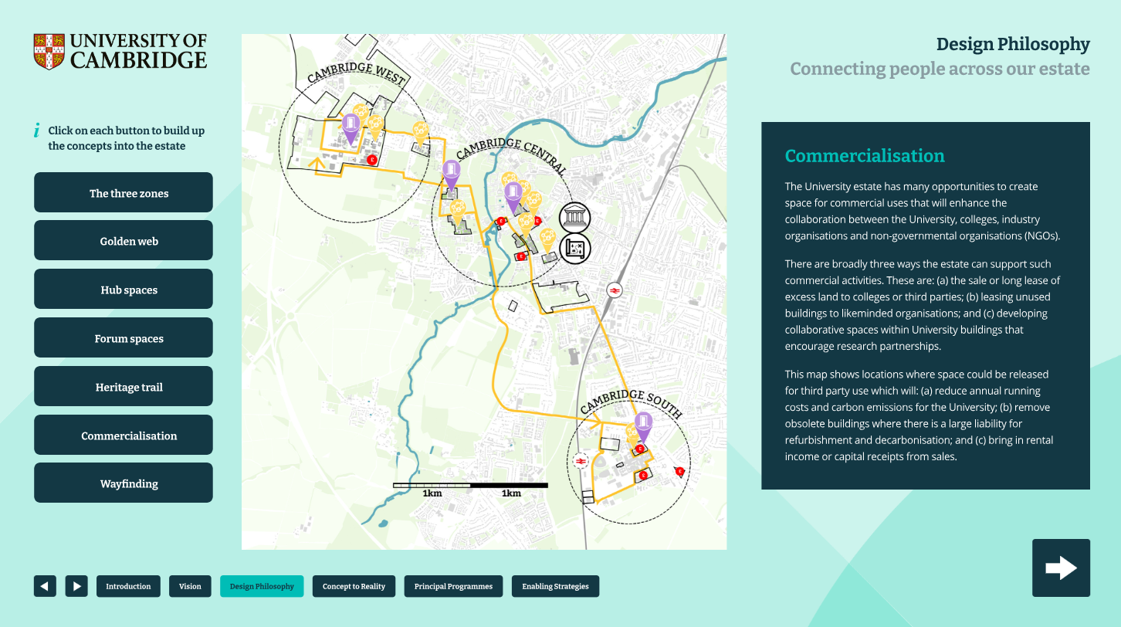
Figure 6. A map of Cambridge which outlines the University’s spaces across the estate. The map is layered and firstly introduces the three zones: Cambridge West, Cambridge Central, Cambridge South. The next layer introduces the golden web, showcasing how each three zone can be interconnected with wayfinding and transportation. The next layer introduces the hub spaces across the three zones; West Hub, University Libraries, Central Hub, South Hub, these are open to the public as well as the University community. The next layer introduces themed forum spaces within each site, providing vibrant and welcoming spaces for the University community to collaborate, socialise, and work. The next layer introduces the heritage that connects the estate, illustrating how heritage will remain an integral part of the estate’s wayfinding and visibility of buildings and research milestones and achievements. The next layer highlights potential spaces to create commercial opportunities for the University. The next layer introduces wayfinding, transforming the map into a new visual that enables you to click on the five example photos of the current streets and spaces of Cambridge and introducing sketches of how these spaces can be improved to drive better connectivity through wayfinding and landscaping between sites and buildings.

4. CONCEPT TO REALITY
The aim is to bring the Strategic Estate Framework to life with different examples over the next 20+ years. This section will become a repository for best practice as well as a learning tool to inform future projects.
Elements of the vision and associated concepts based around connecting people are beginning to be demonstrated by the University through different current projects.
Each project shows the flexibility of approach based on a common set of design principles whilst adapting to specific School and departmental needs. As the University continues to grow, develop and change over time, the concepts will bring together and connect the sites, buildings within those sites, and people within those buildings.

4.2 Entopia Building
The project vision was to provide a new home for the Cambridge Institute for Sustainability Leadership (CISL) within a retrofitted world-leading sustainable office building. The project pushed the boundaries on setting new standards for low energy use, carbon emissions and impact on natural resources as well as improving user experience and wellbeing.
The project aimed to provide an ultra-low carbon sustainability hub whilst retaining the building’s character as a part of the central Cambridge conservation area.
A building which enables collaboration was essential as the CISL increases business, government and academic leadership engagement. The building provides new ways of working, enabling staff members spread across five buildings to work and collaborate in the newly refurbished Entopia building.
Examples of being effective
- Showcase new ways of working
- Enable multi-discipline working methods in one ‘hub’
- Reorganised spaces to promote collaboration
Examples of being efficient
- Increase occupancy through better workspaces, reducing costs
- Multiple space types to encourage use by all within the organisation and beyond
- Collaborative and shared ground floor to encourage cross-discipline research
Examples of being sustainable
- Reduce embodied carbon emissions
- Reuse lighting from another building refurbishment and donate furniture, avoiding embodied carbon emissions
- Follow circular economy principles

The Concept
The design concept focused on creating a welcoming ’meeting place’, drawing people into the building to knowledge share within and outside the University. Inclusivity, accessibility and a healthy environment helps to create a vibrant and collaborative workspace, enhancing interaction. The design aimed to pave the way in setting standards for low energy use, carbon emissions and impact on natural resources while celebrating the history of a truly remarkable building in the heart of the city.
“CISL’s new HQ at The Entopia Building will exemplify and enable our mission to support and inspire the leadership and innovation we need to transition to sustainable economy. Our aim is to create a highly collaborative and sustainable workspace to bring together Cambridge’s academic and innovation communities with our network of companies and sustainability leaders to accelerate solutions to global sustainability challenges.” - Dame Polly Courtice, Founder Director, CISL
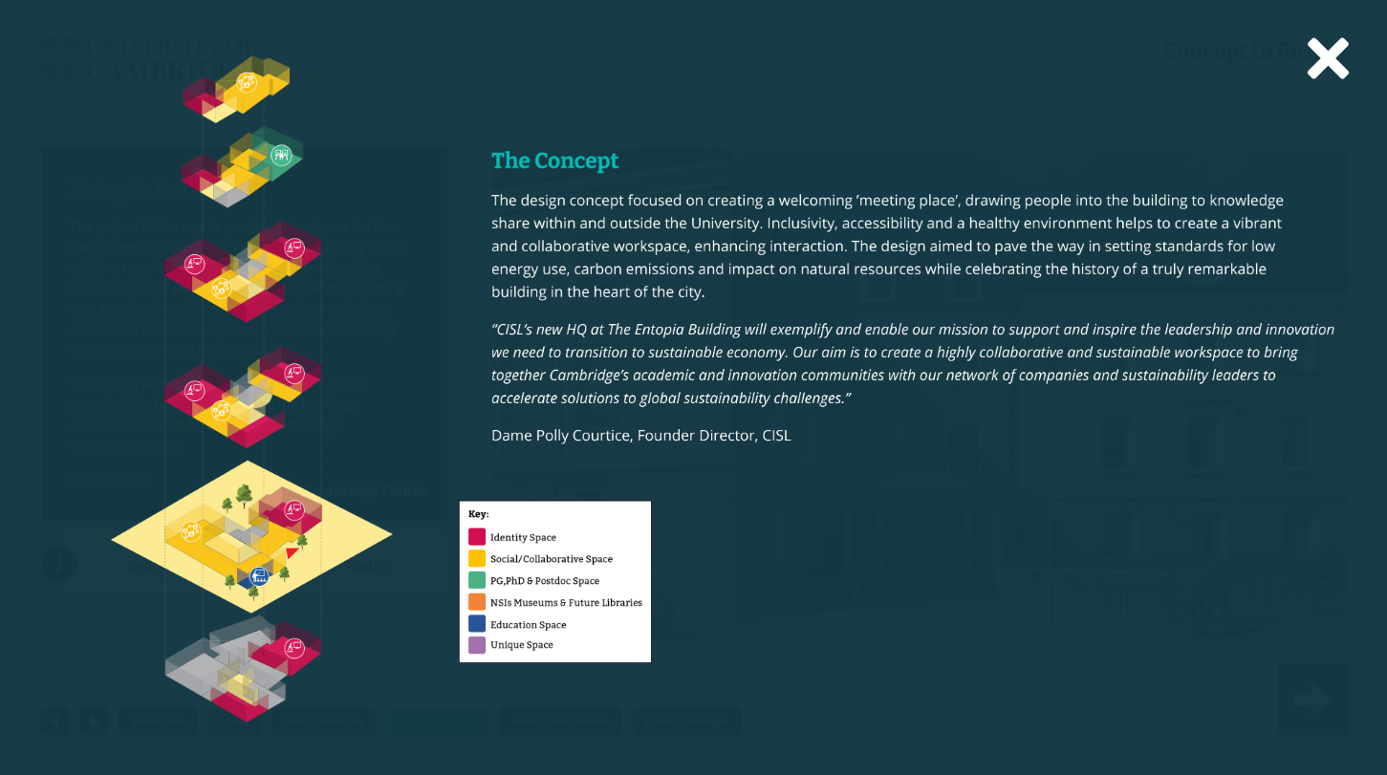
Figure 7. An illustration of the Entopia Building at a conceptual level, showcasing the different types of spaces in reference to the design philosophy have been applied on a floor level. For example, education space and social collaborative spaces available on the ground floor, with dedicated identity and research spaces applied on the upper floors.

The Reality
The Entopia project provides approximately 3,000m² of renovated space for the Cambridge Institute for Sustainability Leadership team as well as the newly created Canopy incubator, which supports small businesses and start-ups offering solutions to global sustainability challenges.
The ground floor has been reimagined to be more public facing with a re-designed entrance, accessible reception area and canteen. It includes two bookable meeting rooms and the CISL office space. Upper floors have been designed to provide space for the CISL offices and collaborative activities. The reconfiguration provides various options for co-working.
Ambitious sustainability targets upgraded thermal performance and airtightness, improving temperature stability and avoided reliance on gas heating systems - reducing the operational energy demand by 86%.
The building promotes circular economy principles with approximately 50% of materials being bio-based (by volume) while the paint alone reduces embodied carbon in the building by 10%.
The building outperforms its counterparts with respect to sustainability, achieving the briefed BREEAM Outstanding, WELL Gold, and Enerphit certification. Following its completion in 2022, the project went on to win the ‘CN Awards, 2023 - Low Carbon Project of the Year’, ‘Build Back Better Awards, 2023 - Green award’, ‘Building Magazine Awards, 2023 - Net Zero Award’ and featured in RIBA’s circular economy exhibition, 2023.
The University of Cambridge’s work on climate change and sustainability is an outstanding collaborative achievement. Today we celebrate projects that have the power to change the way we live and the way our industries operate, hastening the transition to a low carbon world. The new Entopia building is now the most sustainable premises in the University estate, and a key contributor to reaching the target of eliminating our carbon emissions.” - Professor Stephen Toope, Former Vice-Chancellor of the University of Cambridge

4.3 Stirling Building
The refurbishment of the Grade II* listed Stirling building marks the first step in transformative changes designed to reimagine the Sidgwick Site. Centrally located within Principal Programme 3, the building will offer vibrant meeting places equipped with modern amenities, alongside a variety of workspaces that encourage collaboration and quiet study areas - an evolution of the current, individual cellular layouts.
The building was set within its 1960s context, turning its entrance against the flow of movement across the site in part due to its infamous 90-degree rotation in the later stages of its design. Stirling envisioned the Sidgwick Site might evolve around the building, yet the resultant masterplan doesn’t align with the needs of today.
The refurbishment and building extensions are designed to address this, providing contemporary spaces that are shared and offer diversity of settings. This includes promoting inclusion and offering space for inter disciplinary collaboration as well as quiet seclusion, supporting the University’s future need. In doing so, the Stirling building will become the nucleus to the site, fostering a cohesive, modern environment for all who use it.
Examples of being effective
- A variety of settings to support different study and workplace needs
- Collaborative spaces and social settings to enhance learning and research creating places to connect
- A library hub to support the Sidgwick Site and University Library, encouraging vibrant use
Examples of being efficient
- A variety of study environments open to the whole Sidgwick Site
- Increase capacity for workspace, faculty identity and research groups, and social collaborative settings
- Co-locate PhDs currently dispersed across sites in collaborative spaces
- Increase shared seminar spaces to support the site need
Examples of being sustainable
- Maintain, improve and celebrate the University’s heritage
- Dramatically improve internal environment to support a fit-for-purpose building for the future
- Improve external space and increase biodiversity to enhance wellbeing
- Zero gas energy strategy with connections for future site infrastructure support

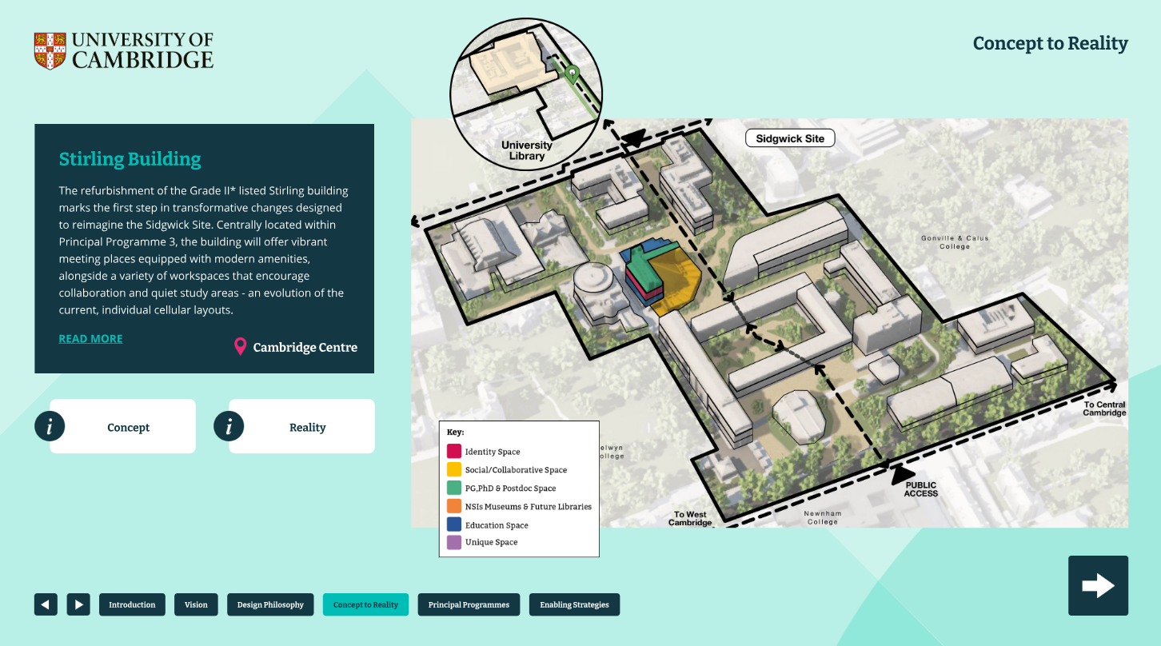
Figure 8. A map of Sidgwick Site, highlighting the Stirling Building which is a central place within the site.

The Concept
The building is reimagined to celebrate its presence on the Sidgwick Site by enhancing the existing entrances and journey around, and through, the building; it promotes the site history, while also creating new high-quality spaces that meet the evolving needs of the University. The sculptural column at the heart of the building is celebrated and marks a pivotal point for flexibility, allowing for adaptable space configurations that support new ways of working. By breaking from traditional space layouts, the building fosters diverse learning environments, celebrating the success of quiet, focused study spaces while also accommodating areas for dynamic, collaborative activities. The modern environment of the University is reflected in the ‘conceptual invert’ rather than the column representing the point of which it becomes the point of activity, from students being watched to students watching.
The ground and first floors will be open and permeable, with the first part of a forum space for the Sidgwick Site as a whole. The upper floors will provide identity space for the Faculty of History as well as collaborative spaces for postgraduate, PhD and postdoc both within history and across other disciplines.
In developing a smaller, more efficient estate, the design responds by maximising the usable space and increasing the building occupancy. Furthermore, the project prioritises financial and environmental sustainability, incorporating energy-efficient solutions and thoughtful design choices that respect the building’s existing historical structure and fabric. This careful approach ensures that the building retains its cultural heritage without excessive alteration, maintaining the icon whilst adapting for contemporary use.
Ultimately, the Stirling building is more inclusive, improving access and wayfinding throughout, drawing people into the space with its shared resources and facilities and enhancing its role as a vibrant nucleus to the Sidgwick Site.
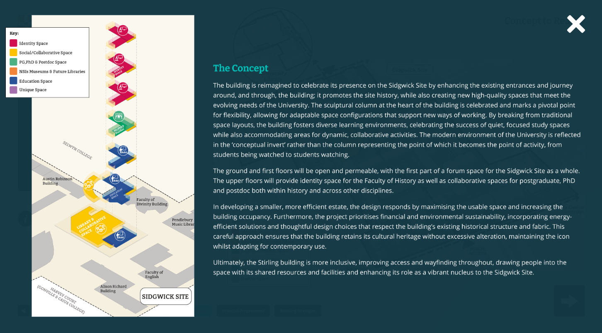
Figure 9. An illustration of the Stirling Building at a conceptual level, showcasing the different types of spaces in reference to the design philosophy and how these have been applied on a floor level. For example, education space and social collaborative spaces available on the ground floor, with dedicated identity and research spaces applied on the upper floors.

The Reality
The Stirling building will increase the capacity of the multi-disciplinary collections within the Seely Library. Additional readings rooms are created within the North and South pavilions at ground and mezzanine level, offering different types of study space and storage for additional collections from across the site, thereby releasing space within other buildings.
On entering the building, the ground floor opens to the library and quiet reading spaces, the collaborative social lower ground spaces with the café and breakout space stretches the length of the building, encouraging people to move through and increasing chance encounters.
These areas will form part of a shared forum space sitting at the heart of the Sidgwick Site, creating a recognised centre of excellence for both the Humanities Schools, supported by the University Library.
Vertical access is enhanced with new lifts extending to all floors and all mezzanine levels, making all spaces accessible. Each vertical rise will exit through a social breakout area before extending into the floors, allowing chance encounters to become meaningful with space to break into and new collaborations to begin.
The first and second floors provide shared teaching and social space with the creation of two additional seminar rooms for flexible use as social, study, teaching and meeting environments. There are shared faculty meeting and boardroom spaces open for all to book.
The upper floors provide a range of workspaces including dedicated identity space for the Faculty of History, PhD students, and emerging research groups, all of which will have access to open and quiet spaces, collaborative group settings and individual cellular meeting or working environments.
A new small café will enhance the entrance, creating a vibrant destination for all staff, students, and visitors to the Sidgwick Site.
The introduction of flexible workspaces and improvements within the library reading room along with adequate fire escape will increase its occupancy by 450 people, representing a 150% increase over the current capacity. Alongside the ability to book spaces, shared meeting rooms and ‘pop in’ to meet and greet the number of possible users to the building has the potential to dramatically exceed this.
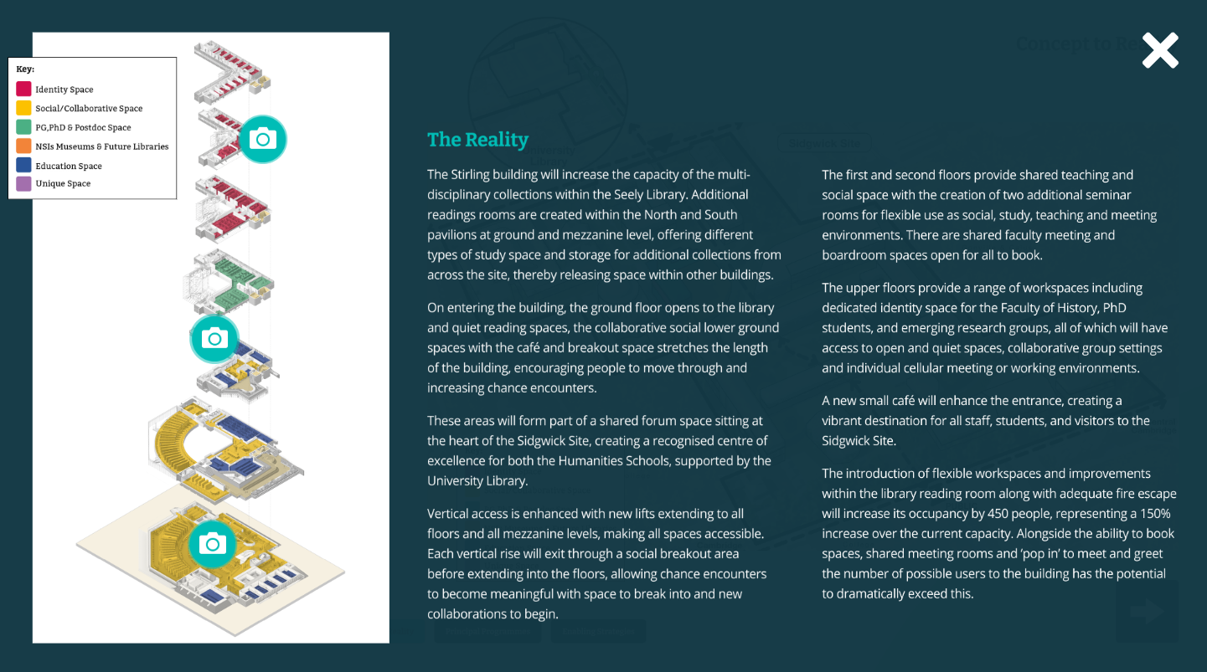
Figure 10. A more detailed illustration of the Stirling Building, showcasing CGI sketches of what the potential spaces would look like after development. This includes examples of the ground floor redesigned to provide social spaces, as well as quieter and flexible workspaces.

4.4 Roger Needham Building
The refurbishment of the Roger Needham building will provide the fourth side of the court in the formation of the School of Technology’s engineering centre of excellence on the Cambridge West Campus. It will be the first phase to provide a new home for engineering with the aim of consolidating all engineering divisions from Trumpington onto Cambridge West. At the heart will be the Technology themed forum space available to all and the building will create a variety of vibrant, high quality, shared and flexible environments which will adapt to changing research themes.
The project will celebrate the identity of engineering whilst also using permeability, into and beyond its four walls, to create a series of interconnected spaces forming the engineering quarter, acknowledging the facilities, specialisms and other divisional identities across the site and promoting links to them.
The refurbishment of the Roger Needham building will provide the School of Technology with a shared facility that will promote inclusivity and access to specialist facilities whilst improving efficiency of space and a synergy with the external realm.
Examples of being effective
- Vibrant and diverse spaces that people want to spend time in
- ‘Showcase’ labs to exhibit cutting edge research and collaboration
- Modern labs to enable world-class research
Examples of being efficient
- Increase occupancy through better workspaces reducing the cost of space
per staff / student
- Multiple space types to encourage use by all
- Collaborative and shared ground floor to encourage cross discipline research

Examples of being sustainable
- Reuse existing building, mitigating embodied carbon
- Improve biodiversity and functional external space to enhance wellbeing
- Zero Gas
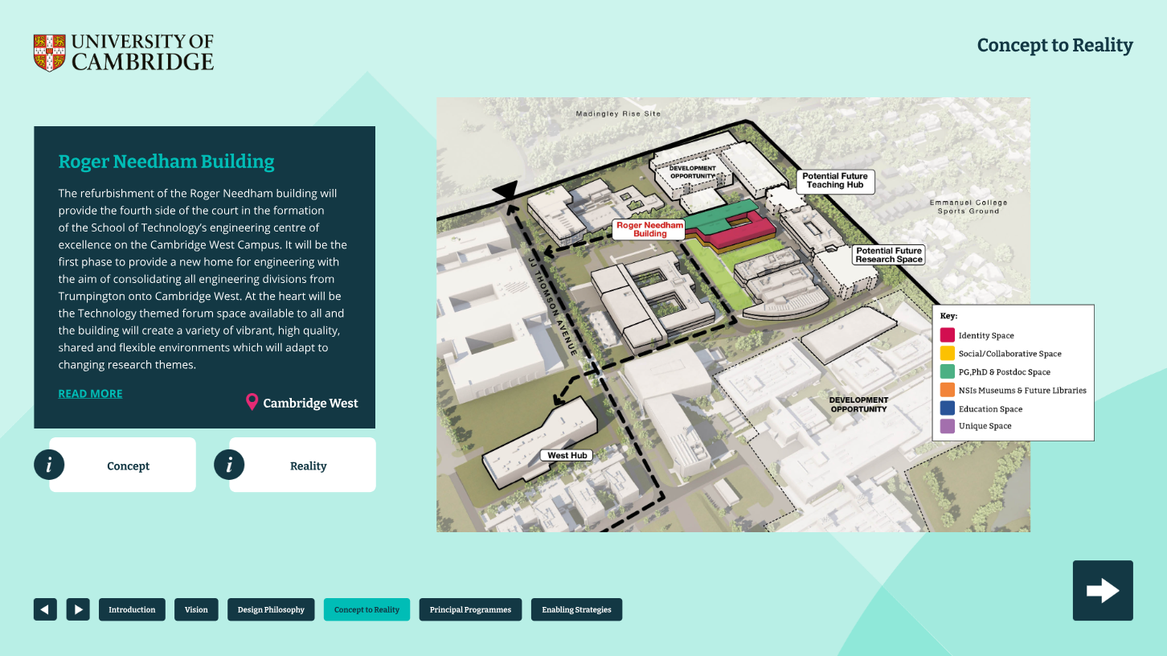
Figure 11. A map of Cambridge West Campus, highlighting the Roger Needham Building.

The Concept
The Roger Needham building proposal meets the aims and design philosophy set out in the Strategic Estate Framework with the creation of a new facility that will contribute to an estate that is effective, efficient, environmentally sustainable, and fit-for-purpose. At the heart of the proposal is the connectivity of people – the development of vibrant spaces that are better used and will lead to a higher quality and efficient estate.
The presence of engineering within the Roger Needham building will complete a ‘court’ of a shared 'town square' formed by the civil engineering, electrical engineering and the William Gates buildings, encouraging dialogue, shared resources and exchange between users.
An open, accessible and permeable ground floor, entered via a biodiverse, functionable and inspiring public realm will create a welcoming space for all staff, students and visitors.
This will include the vibrant forum space which will provide a high quality and flexible environment for meeting, discussing and exchange ideas, quiet working, group gatherings or grabbing a coffee. The shared lab on the ground floor, showcases and celebrates research in this area, whilst giving identity to the departments who call the building home.
The upper floors will provide a mix of identity spaces and varied and flexible workplace and study environments for postgraduates, PhDs and postdocs grouped into flexible research themed neighbourhoods that will cross-cut different parts of engineering. Non-assigned desking will both promote flexibility to adapt to changing themes, promote mixing of researchers and improve utilisation and efficiency of space use, reducing the overall space need requirements. A set of multi-purpose rooms will support personal working, supervisions and, when not in use, will support video Teams calls in a sound-proofed space. This will reduce both running costs and legacy maintenance liabilities, enabling money to be reinvested back into research and teaching.
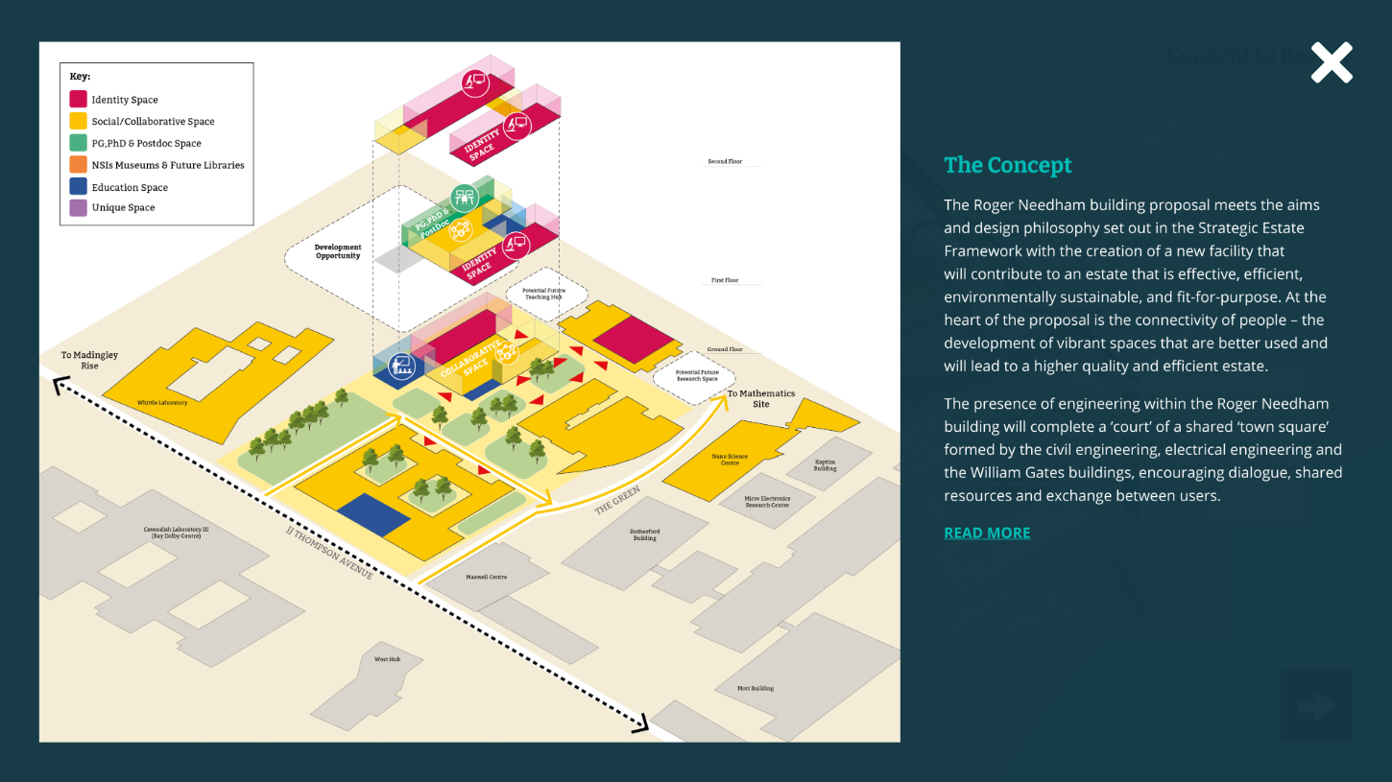
Figure 12. A conceptual illustration of the Roger Needham Building situated within the Cambridge West Campus, highlighting the different types of spaces applied on a floor level in reference to the design philosophy.

The Reality
The department of engineering is currently split across the city centre and Cambridge West, the refurbishment of the Roger Needham building is the first project to begin consolidating the department on Cambridge West and release Trumpington site.
Refurbishment of Roger Needham building seeks to maximise the buildings potential. Filling in the courtyard with specialist labs, forum and atrium space increases the floor area by 660sqm. The building will provide biological laboratories, imaging facilities and robotics laboratories not currently located on the site. Adaptable technical spaces can flex to suit changing research needs and activities while also being an accessible resource for the wider university community.
The Roger Needham building originally hosted c450 people and current utilisation analysis of existing engineering spaces at Trumpington shows peak occupancy of desks at around 30% used at any one time. Based on the new design, the Roger Needham building will deliver around 450 to 550 desks with a further 500 workplace settings (touchdown, forum spaces, team spaces) plus laboratory space which, together, will be able to support around 1,000 to 1,200 people. It is expected to have a peak occupancy of between 60% and 70% which will achieve a vibrant, collaborative and efficient use of space. An increased occupancy will be supported by increased social and amenity space, additional WCs, cycle storage and shower facilities.
Changing the way the space is used will double the capacity of the building, resulting in the ability for researchers to work in a vibrant atmosphere and to mix across different research themes. The increased capacity will result in the Department of Engineering to be able to co-locate faster and at a substantially lower cost, both in terms of money and, importantly, carbon emissions (both embodied carbon and annual carbon emissions) through reducing the amount of new space that needs to be built.
The existing building on Cambridge West has a poor relationship with the other buildings in its proximity. It turns its back on the green amenity space to the south and is under occupied and lacking vibrancy. The new design will look inward towards the court area between civil and electrical engineering, which will be redesigned to deliver further covered work and relaxation spaces whilst supporting greater biodiversity, rainwater management and, where possible, shading to provide cool spaces in the summer.
There is huge opportunity for the presence of engineering within this building to revitalise this area of the site and to strengthen collaborative synergies to others in the School of Technology and beyond.
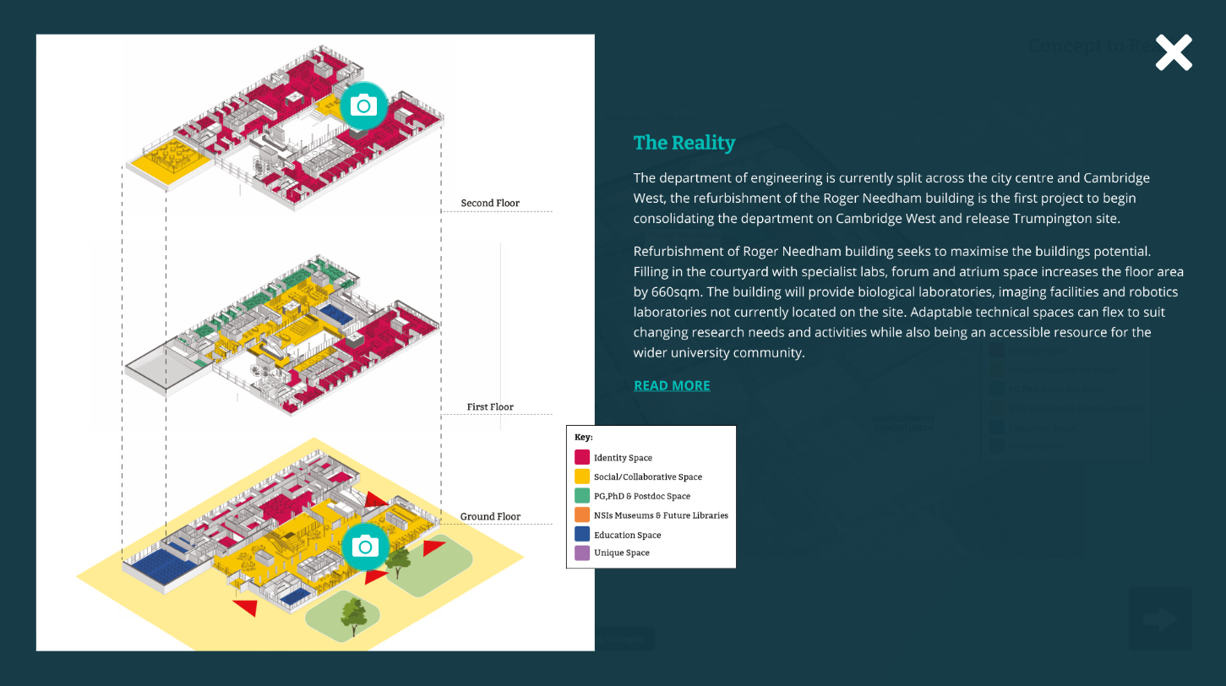
Figure 13. A conceptual illustration of the Roger Needham Building with detailed floor plans, highlighting the different types of spaces, with CGI sketches to showcase how the designed spaces may look like in the future. This includes sketches of the ground and first floor with social and collaborative spaces for people to meet and work, as well as upper floor sketches of dedicated research workspaces that foster collaboration as well as independent studying.

4.5 School of Biological Sciences – Future Estate Needs
The Future Estate Needs programme aims to reimagine the organisation of the physical estate of the School of the Biological Sciences (SBS) to create high-quality working environments to support world class teaching and research, in a manner that inspires both researchers and students alike.
Located in the heart of Cambridge, SBS’ Future Estate Needs aims to celebrate the heritage of the Downing Site. Significant refurbishment, extension and new build across Downing, New Museums and Old Addenbrooke’s sites offers the opportunity to facilitate research at the highest levels.
The programme ambition seeks to create a truly collaborative environment, both within the School, the wider University and with industry partnerships, strengthening collaboration between research and commercial science.
A standalone teaching hub in proximity to research will ensure students and teaching staff retain connection to the SBS whilst learning, teaching and studying in a vibrant and supportive environment. Social breakout space between learning environments will give students a sense of belonging on the site, whilst also supporting the use of the hub as a conference facility for research out of term.
Examples of being effective
- Create open ‘home’ space, through permeable ground floors, that the
whole School feel welcome to use
- Reorganisation of space to promote collaboration
- Modern labs to enable world-class research
Examples of being efficient
- Shared technology platforms to reduce duplication of facilities, improve
quality of space and create a collaborative community of scientists
- Locating the right function in the right space within the existing estate. i.e.
labs in existing floors with suitable floor to ceiling heights
- Large flexible labs with organised adjacencies and support spaces
Examples of being sustainable
- A biodiverse and welcoming external realm utilising sustainable urban
drainage
- The potential to either reuse existing buildings, mitigating embodied
carbon or develop new build opportunities utilising the most sustainable
materials
- Zero Gas
The Concept
The Downing, New Museums and Old Addenbrook’s sites are home to the School of Biological Sciences and a University shared teaching hub, redeveloped to meet the future needs of world-class science.
The main ambition for the programme is to connect people across sites, departments and research groups, to enable interaction and collaboration at every stage, providing a variety of high quality, vibrant, effective, efficient and attractive spaces.
A clear front door leads to the new ‘home’ for the School, ensuring visitors as well as the SBS staff feel welcome, can easily navigate the site and have a place to touchdown for flexible working or meetings. Expanding into a permeable ground floor social hub, this space will be essential for a variety of uses including; departmental gatherings, informal meetings, meeting colleagues for coffee and lunch or for providing an alternative setting for quiet working. This space will celebrate the SBS, with the opportunity to showcase the School’s work, past and present.
Elsewhere across the site, the permeable ground floors may be used for further social collaborative spaces, providing a variety of size and shaped spaces with different feeling and functions. Ground floors and existing basements may also provide space for shared specialist science facilities or for shared general science support hubs.
Set within a biodiverse and attractive external realm, welcoming and accessible entrances will connect the sites, buildings and facilities to enhance interaction and the sharing of equipment as well as benefiting user wellbeing and staff and student experience.
A variety of settings on the upper floors provide workspace, meeting space and labs. The development of buildings within the sites will maximise flexibility and adaptability to allow for the evolution of science, size of research groups, specialist facilities and future collaborative opportunities.

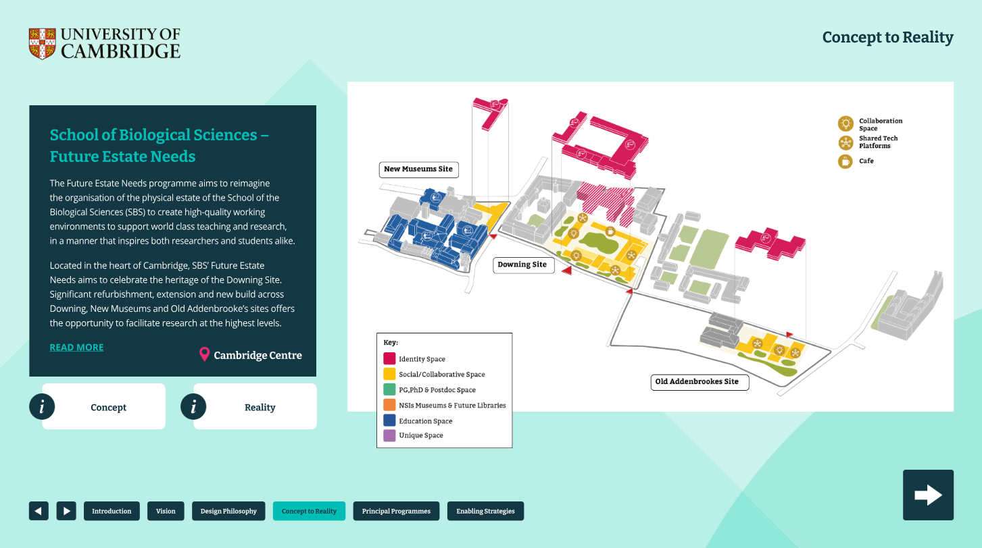
Figure 14. A conceptual map showcasing how New Museums Site, Downing Site and Old Addenbrooke’s Site connect and the application of the design philosophy, showcasing how the available spaces can work together more efficiently and effectively with dedicated spaces. This includes buildings situated within New Museums Site colour coded in blue to reference education spaces, Downing Site and Old Addenbrooke’s Site ground level buildings coloured in yellow to associate with social and collaborative spaces, with upper floors highlighted in pink to indicate dedicated identity and research spaces.

The Reality
The Future Estate Needs programme has assisted the School in making the decision to remain in their historic home in the city centre and for a teaching hub to be separate but in proximity to research. The next stage of works will determine how space will be organised across the three sites.
The project will provide hubs for shared specialist facilities to benefit all in the School, as well as to external parties. This accessible space will reduce duplication of existing facilities across the buildings. A bespoke spatial brief has calculated a reduction in space need by 27% contributing to a higher quality estate, attracting users to key spaces, improving utilisation and creating a better used, vibrant and efficient estate.
An analysis of existing buildings on the site will assess the most appropriate buildings for science, efficiency on the site, cost effectiveness and heritage, to ensure that space organised within existing buildings are fit-for-purpose. The location of a new building will be explored to ensure that opportunities on the site are maximised.
Strategic development of the site will create the opportunity to release space for industry partners, providing key commercial collaborators for research as well as reducing operational costs and legacy maintenance liabilities for the University and providing funds to be reinvested back into research and teaching.

5. PRINCIPAL PROGRAMMES
Through on-going engagement with the University community, six Principal Programmes have been established covering the majority of the estate, providing a long-term vision and framework which will underpin the ongoing development across locations.
Each Principal Programme outlines the academic objectives and opportunities for the estate, balancing Reshaping our Estate’s three key aims:
- An effective estate – a plan that responds directly to the Schools’ vision for delivering the overall University mission.
- An efficient estate – delivering an effective estate whilst reducing overall running costs through increasing the capacity and quality of all buildings through intensifying their use.
- A sustainable estate – improving the University’s carbon emissions, biodiversity, equality and diversity aims, and overall staff and student experience.
If all three aims are met, the Schools and Non-School Institutions (NSIs) will produce ‘investable’ programmes of work. Delivering business cases that show academic benefit at a cost that is value for money, with the least impact on the planet, and improving both staff and student experiences.
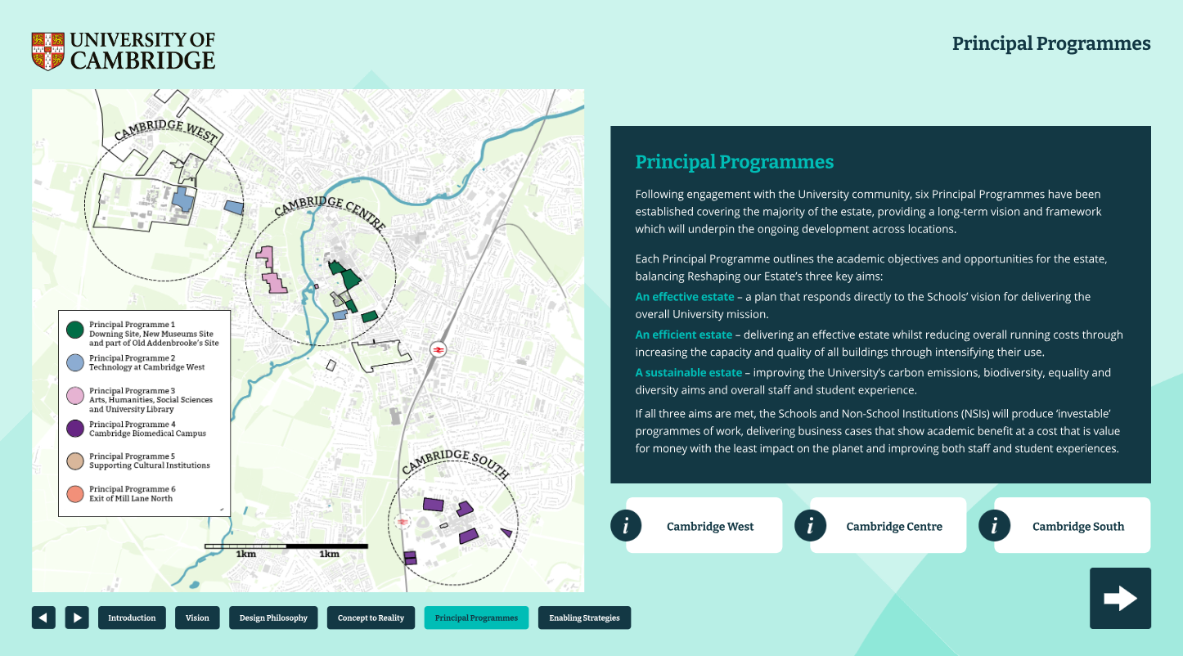
Figure 15. A map of Cambridge, showcasing the three zones: Cambridge West, Central and South, with site areas colour coded representing each of the six Principal Programmes.

5.2 Downing Site, New Museums Site and part of Old Addenbrooke’s Site
The Downing Site, New Museums Site (NMS) and part of Old Addenbrooke’s Site Principal Programme focuses on the central location of Cambridge, primarily supporting the following Schools and Non-School Institutions (NSIs):
- The School of the Biological Sciences (SBS)
- The School of the Physical Sciences (SPS)
- The School of the Humanities and Social Sciences (SHSS)
- Cambridge Conservation Institute (CCI)
- Student Services
The modernisation and reorganisation of current space is a critical driver to this programme, with an ambition to create better interlinked facilities with welcoming themed research spaces within the centre of Cambridge. This will enable accessible cross-over between the Schools, NSIs and external partners, forming a well-recognised collaborative world centre that underpins the success of the University and City.
This programme will support the existing ‘Future Estate Needs’ project developed by the School of the Biological Sciences, which includes additional works associated with a shared teaching hub, supporting all Schools. This project intends to facilitate new research and teaching operating models, that will enable staff and students to work, teach and study in better ways that will lead to improved outcomes for natural sciences.
The ongoing rolling refurbishment of the Yusuf Hamied Department of Chemistry will additionally form part of this Principal Programme.

Academic Objectives
The School of the Biological Sciences’ (SBS) key objective, through their ‘Future Estate Needs’ project, is to create world-leading spaces that will support bioscience research for generations to come. The reorganisation of spaces will be based upon multi-departmental bioscience neighbourhoods featuring an inclusive and collaborative ‘forum’ infrastructure.
The anchor spaces will create neighbourhoods with a focus on equipment and facilities, allowing users to move between departmental identity space and shared facilities, encouraging collaboration. By reorganising, removing duplication and under-used space that is no longer fit-for-purpose, will reduce the amount of existing space occupied. This will result in creating realistic and investible projects for the University, including income generating opportunities with commercial partners.
The SBS’ teaching is delivered across a number of Tripos’ which includes the School of Clinical Medicine (SCM) and the School of the Physical Sciences (SPS). The wider aim is to modernise teaching practices, making effective and efficient use of teaching labs, general spaces including staff and equipment resources, supported by social and technical support facilities to deliver teaching experiences of the future.
SPS also has a significant presence on the Downing Site through Geography and Earth Sciences. The two departments have links across many of the other Schools through both physical, planetary, environmental, and human sciences. The aim is to support collaboration across these themes with links to the teaching spaces. Both SPS and SBS are linked closely with the Cambridge Conservation Institute (CCI) in the David Attenborough building, whose key driver is expansion into a much greater biodiverse urban realm.
The School of Humanities and Social Sciences (SHSS) has a presence on the north part of Downing Site and the west part of NMS. The links with the associated museums (Museum of Archaeology and Anthropology, and The Whipple Museum) and their associated libraries are an important requirement, as is ensuring the various Departments feel part of the wider Humanities community. A key driver for the SHSS is for Departments to feel better connected to both their School and the site on which they are located, with the ambition to create inclusive and accessible buildings.
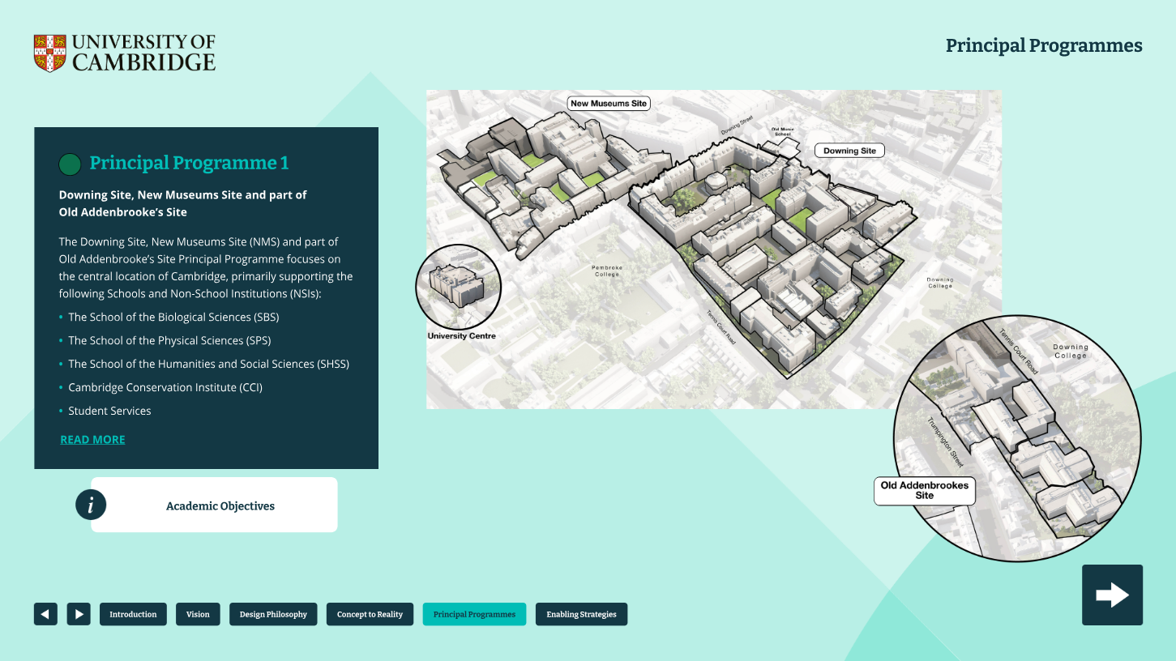
Figure 16. A map outlining spaces that form part of Principal Programme 1 which includes New Museums Site, Downing Site and part of Old Addenbrooke’s Site.

5.3 Technology at Cambridge West
This Principal Programme supports the School of Technology’s long-term plan to co-locate all of the Engineering Departments onto the northwest part of Cambridge West alongside Computer Sciences, whilst vacating the Trumpington site. The programme will deliver a centre for the School of Technology, with landscape links across to the West Hub, Ray Dolby Centre and the wider facilities across the site. There are strong links with the School of Physical Sciences located both on Cambridge West and the nearby Centre of Mathematical Sciences to ensure an effective, efficient and sustainable use of all neighbouring facilities.
This will form part of the University’s ambition to develop an Innovation District at its 66-hectare Cambridge West site, inviting research and innovation based on the University’s significant presence from both the School of Physical Sciences (SPS) and School of Technology (SoT).
Academic Objectives
The School of Technology’s (SoT) vision is to co-locate Engineering onto the West campus, creating greater collaborative links between each of the disciplines, as well as creating synergy with other parts of the SoT including Computer Sciences.
The aim is to have high quality research spaces whilst maintaining linked teaching facilities. All Departments have a vision for growth and are substantially expanding postgraduate places.
Through moving to more flexible use of space, reflective of new ways of working, the SoT is making itself investable by creating vibrant working spaces that will be used intensively as well as achieving greater collaborative outputs.
The School has ambitions to support the growth of Computer Sciences, as well as seeking external funding for areas such as quantum photonics for potential new facilities in the future.
Whilst the focus of this Principal Programme is on SoT in the north west, the designs will be developed in collaboration with the School of Physical Science (SPS) especially around education space, to ensure that shared teaching facilities are identified and enables the best use of facilities available.
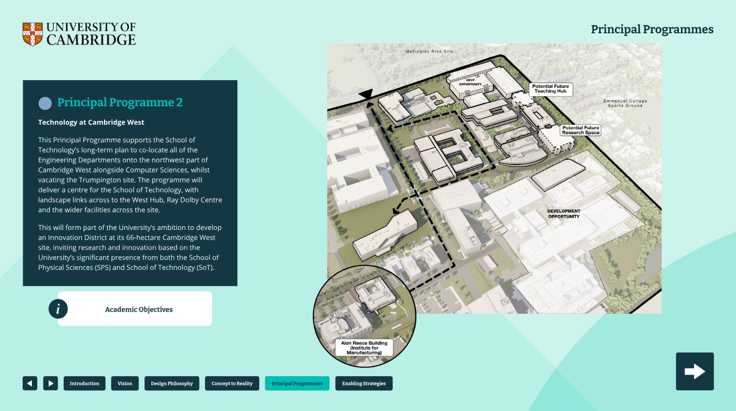
Figure 17. A map of Cambridge West, outlining spaces that form part of Principal Programme 2.

5.4 Arts, Humanities, Social Sciences and University Library
This Principal Programme supports the academic visions for the School of Arts and Humanities (SAH), the School of the Humanities and Social Sciences (SHSS) as well as the emerging site spatial framework of the University Library (UL). The University Library is the largest building on the University estate and Grade II listed.
The Sidgwick site is characterised by a set of individual department and faculty focused buildings that were built between 1958 and 2012 with many of the early buildings listed at Grade II or II*.
This programme factors in all of the SAH and SHSS Departments (including those not based on the Sidgwick Site) and their academic objectives to support the wider ambitions of each School and the UL.
Academic Objectives
This Principal Programme will be informed by the shared strategic thinking of all the Departments and Faculties within the School of Arts and Humanities (SAH) and the School of the Humanities and Social Sciences (SHSS), with key dependencies into the University Library’s Site Spatial Framework.
The SAH want to retain their world-class reputation by remaining at the forefront of enhancing human thinking and creativity. It is important that SAH’s expertise can be effectively mobilised to collaboratively tackle today’s biggest social and technological challenges. Space is a key enabler for the School who have identified that high-quality spaces will allow for greater flexibility between disciplines in teaching and research, and ensure researchers can respond with agility to new and emerging opportunities to chronicle what it is – and could be – to be human.
The SHSS aims to build on its positioning as a world-leading provider of cutting-edge research in the Humanities and Social Sciences that impacts and drives global innovation and policy. Similarly to the SAH, the SHSS sees the estate as a key driver for this ambition. The growth of interdisciplinary research is considered a key opportunity to build a bridge to the arts and the sciences that can enrich the student experience. This will require improvements to teaching and learning, using innovative teaching practices and exploiting the School’s breadth of disciplines, to better realise its interdisciplinary potential and set an example for the rest of the University in equality, diversity and inclusion.
Together the SAH and the SHSS are looking to explore how their estate can best support a common academic ambition that promotes collaboration, interdisciplinarity and inclusion for all. Through this process, options will be considered to understand where best to locate Departments and Faculties but recognising that the Sidgwick Site will remain a centre of gravity for Humanities.
The University Library’s Site Spatial Framework is looking at finding ways to encourage greater utilisation of the space through reinterpreting a library service in a modern setting. The ambition is to create a set of research and learning facilities alongside the traditional library facilities that can be shared across the University. Specifically, supporting the ambitions of its neighbouring Sidgwick Site to draw it into the heart of the University is a key priority.
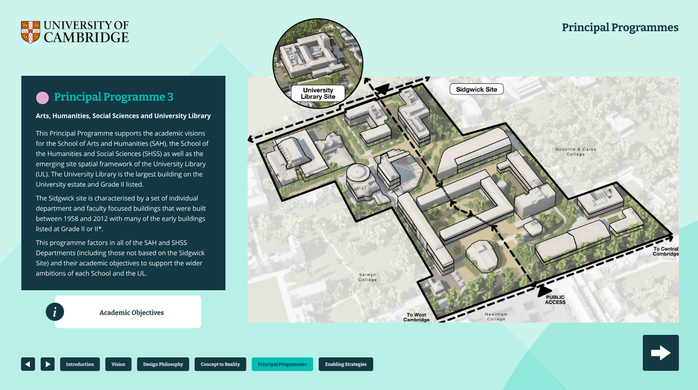
Figure 18. A map of Sidgwick Site, including University Library, outlining spaces that form part of Principal Programme 3.

5.5 Cambridge Biomedical Campus
The land across the Cambridge Biomedical Campus (CBC) is under the ownership of a number of different organisations including Cambridgeshire County Council, the Pemberton Family Trust, Prologis, Cambridge University Hospitals and the University of Cambridge.
At the centre of the site is Addenbrooke’s Hospital. The University has a number of different land holdings. This Principal Programme focuses on the School of Clinical Medicine’s requirements for both teaching and research collaboration on this developing site.
Academic Objectives
The School of Clinical Medicine (SCM) is located on the Cambridge Biomedical Campus (CBC) and aims to provide global leadership in education, discovery and healthcare.
The School will achieve this through inspirational teaching and training, outstanding basic and clinical research, and integration of these to improve medical practice for both individual patients and the population.
Through inspirational teaching and training, the SCM aims to educate individuals who:
- will become exceptional doctors or biomedical scientists
- combine deep scientific understanding with outstanding clinical and communication skills
- demonstrate a caring, compassionate and professional approach to patients and the public
- are equipped to become international leaders of their profession
Through its commitment to the pursuit of excellence, and support of scientists of international standing in basic and clinical research, the SCM aims to:
- understand fundamental biology and thereby the mechanisms underlying disease
- integrate basic and clinical research
- apply a rigorous mechanism-based approach to clinical problems and innovate to solve the health challenges of our society
Insight, innovation, and inspiration are key, and it is important that the built environment helps the SCM deliver these three goals. The School’s vision for the estate is to be at the heart of the health ecosystem on the Cambridge Biomedical Campus, with facilities that support working in a flexible and agile way. This will enable bringing together scientists with different expertise from across the School and University, and working with supporting organisations, boosting interdisciplinarity in search of new medical discoveries.
Central to the success is to promote collaborative working practices and social interactions internally and externally, looking beyond the School and drawing upon the University’s strengths across multiple relevant disciplines, including mathematical, physical and social sciences.
The School has some immediate challenges with respect to buildings on the Forvie site and the Island Site as well as opportunities to work collaboratively with the NHS for the development of the Cambridge Cancer Research Hospital – and Cambridge Children’s Hospital. There is a need for the estate to co-locate interdisciplinary research clusters and provide attractive indoor and external spaces. This will encourage people to meet each other face-to-face, to find and foster new collaborative partnerships, to facilitate direct educational contact with students, to socialise, and to sustain a buoyant spirit of collective endeavour.
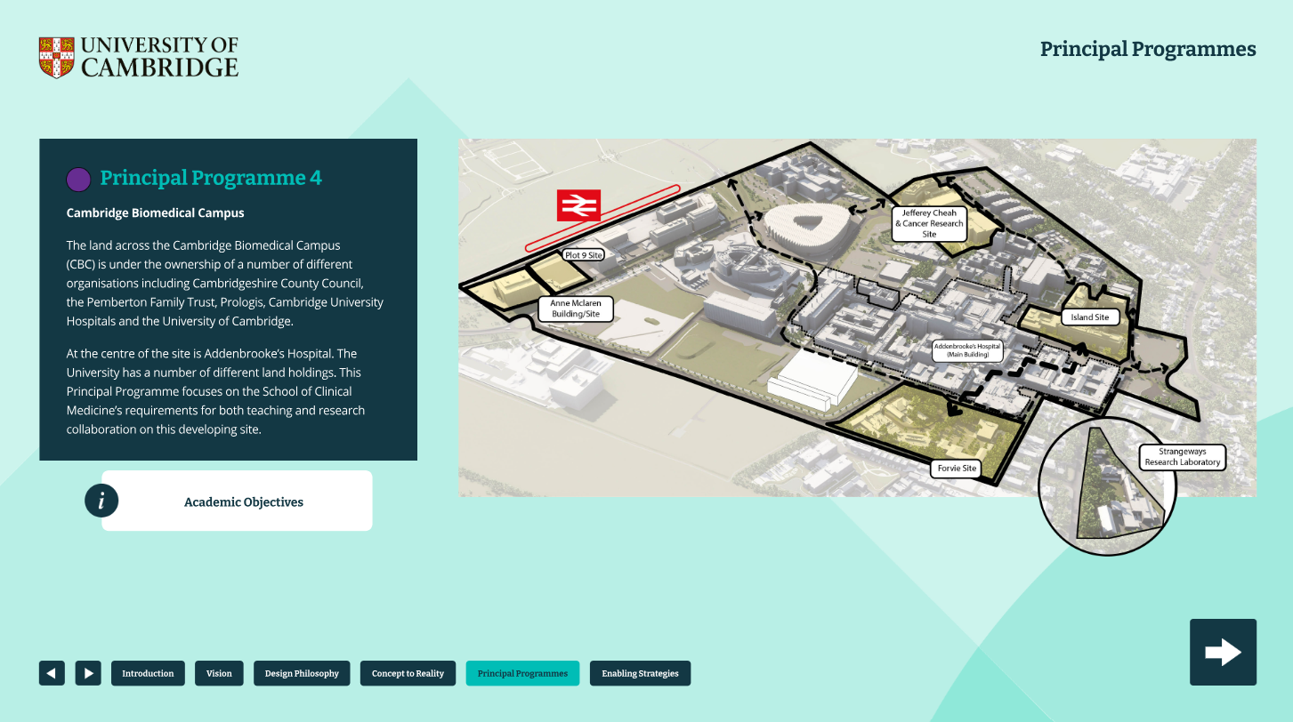
Figure 19. A map of Cambridge Biomedical Campus, outlining spaces that form part of Principal Programme 4.

5.6 Supporting Cultural Institutions
The University is privileged to have a number of historic, cultural, artistic and scientific institutions which include the world-renowned Fitzwilliam Museum and the Botanic Garden, as well as many specialist museums and archives. Alongside these are the sports facilities, the Centre for Music Performance and the ADC Theatre that enrich the cultural life of the University and the wider city.
A number of formal reviews and ongoing discussions are being undertaken within each institution, and across the University, to consider how to best support their objectives in a constrained financial environment. A Principal Programme Management Board will be established in due course to deliver on the compelling strategies agreed by the General Board.

5.7 Exit of Mill Lane North
The buildings on the Mill Lane North site are all beyond the end of their economic life, obsolete and in most cases cannot support academic excellence. The site is now a substantial liability for the University, costing millions of pounds every year to keep the buildings watertight, lit, warm, and compliant. Parts of the site have now become unusable and have had to be vacated. The majority of the buildings are poorly insulated resulting in high energy usage.
The cost of making the site fit-for-use far exceeds the market value. At a time when the University is trying to reduce the annual running costs of the estate, there is an opportunity to vacate the site, releasing the value of the land (tens of millions of pounds) and reducing carbon emissions to help meet sustainability targets: avoiding substantial investment in the site which would be required if retained (a hundred plus million pounds of cost). The money received from the sale, and saved from reduced annual running costs, can be reinvested back into other sites supporting research and teaching of the future.
The Estates Division project team is working with current occupiers to find alternative locations for all the impacted teams.
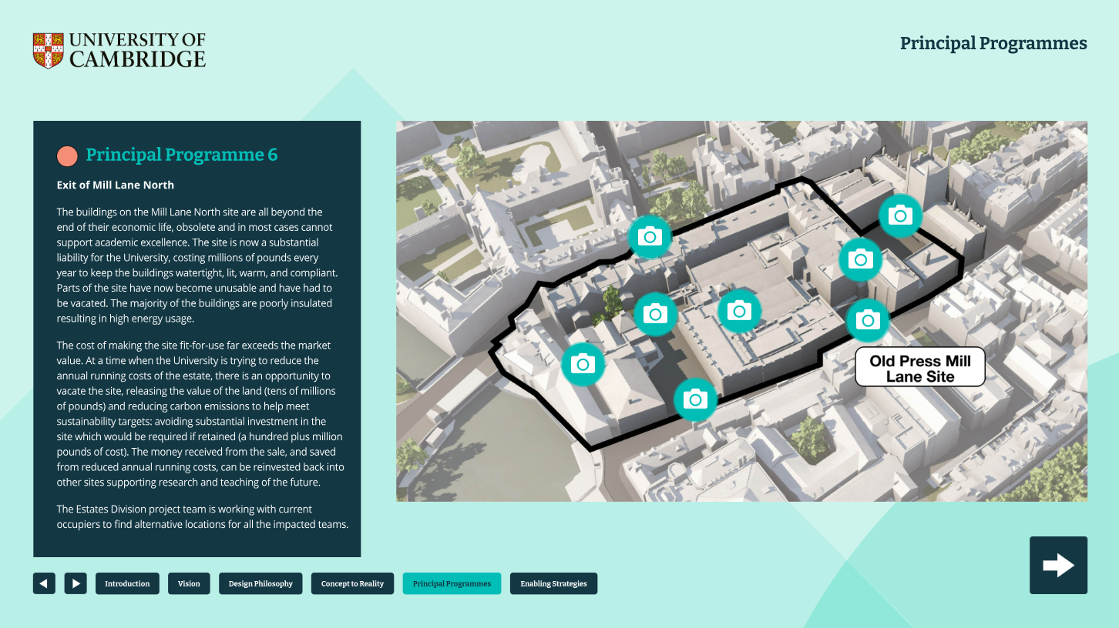
Figure 20. A map of Old Press Mill Lane site with images showcasing existing spaces that are no longer fit-for-purpose. This visual outlines spaces that form part of Principal Programme 6.

6. ENABLING STRATEGIES
The Strategic Estate Framework will support, and is supported by, a series of university-wide policies and service strategies.
The policies and strategies which are critical elements for any strategic estate framework include:
- environmental sustainability plans and guiding principles to further develop and improve hard and green infrastructure, complying with university policies and emerging legal requirements;
- the Equality Impact Assessment (EIA) which demonstrates, as a minimum, compliance with the Equality Act 2010;
- the Civic Framework, ensuring the strategic planning, design, and use of the estate actively supports inclusive access, skills development, and stronger connections between the University and its local and regional communities.
This section will be developed over time to link into more polices and strategies.

6.2 Environmental Infrastructure
Environmental infrastructure is a key enabler of Reshaping our Estate, ensuring we create a connected, purpose-fit estate that supports the University of Cambridge’s academic mission now and in the future.
We must enhance the resilience of the estate and its operations to best serve our academic community, addressing unpredictable external factors, including those arising from climate change.
A well-planned transport infrastructure is essential for connecting people across the estate. Our staff, students, and visitors need safe, accessible and sustainable transport options that are affordable and reliable. Our transport provision must also align with the University’s goals on inclusivity and equity.
Energy infrastructure is also critical to connecting our buildings and sites and, through them, our people. Energy underpins all University activities, supporting our local, national, and international collaborations. Water is also a crucial resource for much of our academic activities. We need infrastructure that ensures our energy and water supply is reliable, resilient and can flex to meet the future needs of our academic activities, whilst minimising our climate impact.
Connecting people with one another and with nature through the provision of green infrastructure is equally important. When integrated thoughtfully across our estate, green infrastructure provides attractive spaces for outdoor recreation, education, and collaboration - bringing people together whilst allowing wildlife to thrive. In addition to enhancing individuals’ wellbeing and biodiversity, green infrastructure also promotes other University goals by delivering vital environmental services, for example reducing risks of flooding and overheating and making active travel between sites more enjoyable. It also helps to create a more attractive estate and provides an on-site resource for teaching and research.
In summary, environmental infrastructure helps to create a more environmentally sustainable and resilient estate that facilitates connection and collaboration, thereby assisting the delivery of our academic mission now and into the future in a sustainable way.

6.3 Equality, Diversity and Inclusion
The University of Cambridge is committed to pursuing academic excellence through equality of opportunity and a proactive, inclusive approach to equality. This commitment supports and encourages all underrepresented groups, promotes an inclusive culture, and values diversity.
It is underpinned by the University's core values, as expressed in its mission statement:
- Freedom of thought and expression.
- Freedom from discrimination.
Protected groups are defined in the Equality Act 2010 as follows: Sex, Gender Reassignment, Marriage or Civil Partnership, Pregnancy or Maternity, Race (including Ethnic or National Origin, Nationality, or Colour), Disability, Sexual Orientation, Age, and Religion or Belief. The University respects all religious and philosophical beliefs, as well as the absence of religion or belief, and upholds the right of all members of its community to discuss and debate these issues freely.
The Equal Opportunities Policy will be enacted through the University's Equality Objectives, associated implementation plans, and the Combined Equality Scheme. The Combined Equality Scheme outlines how the University will fulfil its statutory obligations related to equality legislation. This framework will also be a consideration as we look to provide inclusive spaces in the future.
The goal of the Reshaping our Estate initiative with Equality, Diversity and Inclusion (ED&I) is to create a more connected, functional, and inclusive estate. This includes developing a connected University campus that offers a welcoming and open environment for studying, working, and conducting research. Forum spaces will provide a variety of workspaces to support independent study and collaborative social interactions.
We aim to enhance accessibility and inclusivity by placemaking, creating spaces that maximise external green areas, incorporating welcoming spaces to be enjoyed by all.
Currently, there is a lack of pedestrian-friendly paths, inadequate door placements and clear signage, alongside a need for better social and collaboration areas. The design of these spaces will need to be mindful to include multi-faith areas, parenting spaces, gender-neutral toilets, neurodiverse suited workspaces, and enhanced building access ensuring inclusivity is considered at all stages.

6.4 Civic Framework
The University’s report ‘People, Place, Partnership: Civic priorities for the University of Cambridge’ sets out a renewed civic approach, shaped by the region’s dynamic innovation landscape and a shared commitment to ensuring its benefits are more widely and equitably felt.
This approach builds upon the University’s longstanding engagement across Cambridge and the wider region, with aims to strengthen local relationships, align efforts, deepen partnerships, and embed inclusive, place-based collaboration.
The report is informed by a consultation involving over 1,700 individuals, including residents, community organisations, businesses, local authorities, staff, and students. It presents key insights and introduces a Civic Framework to guide future engagement.
The Framework identifies three priority areas:
- Supporting regional skills development, with a particular focus on young people;
- Creating more welcoming and inclusive spaces, by opening up the University’s estate and resources for shared learning;
- Strengthening connections between staff, students, and wider communities.
The Civic Framework complements the Strategic Estate Framework, informing how the estate can enable collaboration and inclusion beyond the University community, with the Strategic Estate Framework ensuring spaces are purposefully designed and managed to support these civic priorities.
Click here to access the full report.

7. Appendices

7.1 Video: This is our place we hold the keys
Descriptive video showing photos and videos across various sites in the University of Cambridge. The voiceover dictates the following
“This is our place, we hold the keys to buildings that witnessed history.
Gated squares where dreams came true. Steps that Bryon, Darwin, Turing climbed like me and you. Towers and spires of global fame. Desks and labs where ideas came. Discoveries that left the world forever changed. Buildings that inspire, unite. Where wisdom is shared and answers found in this place on Cambridge ground. A place of academic majesty, a place with its own alchemy. It’s true, there’s magic in these walls, these lecture theatres and dining halls. And when you least expect it still enthrals. And so we must protect this place and the earth on which it stands. Pass on this place of light through the ever-changing hands. For now, it’s ours to belong too, ours to behold, to reinvent and reimagine for the people yet to come. The stories yet to be told. This is our place, we hold the keys. It’s a privilege it’s our responsibility.

7.2 Video: Enhancing Staff and Student Wellbeing
Talking head video featuring Ndunge Kivuitu, Head of ED&I at the University of Cambridge.
“There are many things that I would like to do, but if I was to pick one thing I could do to enhance staff and student experience, especially in relation to wellbeing,
I would create dedicated, accessible wellbeing and relaxation spaces within buildings. These would be quiet, comfortable areas where staff and students could take a break, recharge and engage in mindfulness practices. They would have access to soothing decor, comfortable seating, important to make sure that these are sensory friendly.
I would also make sure that relevant support services are also within reach, for example eateries, libraries and event support services and so on.”

7.3 Video: Improving connectivity across the estate
Talking head video featuring Marie Butcher, Head of Departmental Management for the Faculty of Human, Social and Political Sciences at the University of Cambridge.
“I think we could improve the University of Cambridge estate to enable better relationships between staff and students if we actually think better about how we use the space. Lots of departments have special access we can't get into them. I'd like to see some of the barriers broken down between departments so that staff and students, when they're in different areas of the site, can actually move in and out of departments and work with other people there.
I think it would also foster some joined up collaborative thinking between staff and students and between departments.”

7.4 Video: Sustainable and fit for purpose facilities
Talking head video featuring Tamsin O’Connell, Head of the Department of Archaeology at the University of Cambridge.
“We strive to have spaces that are excellent, welcoming, flexible, and fit for purpose in the modern world. Our estate currently supports our teaching and research by ensuring that our spaces enable us to be the best that we can be in our laboratories, in our seminar rooms, in our libraries. We strive to provide places that are welcoming, that are excellent, that are flexible and fit for the modern world.”

7.5 Video: Effective multipurpose spaces
Talking head video featuring James Campbell, Head of the Department of Architecture at the University of Cambridge.
“We need lecture halls that are big enough to accommodate our students, and our student numbers are growing every year.
And we need spaces to hold seminars, places that students can organise exhibitions, and we need spaces where students can meet with academics. So, we need spaces of all sizes and types.”

7.5 Video: Effective data connectivity
Talking head video featuring Richard Hey, Deputy Director of UIS at the University of Cambridge.
“Having a modern estate that's digitally connected is key to success for the university in the future. We need to have a collaborative shared space style estate that has a digital and IT infrastructure designed into it and not added as an afterthought. We need good AV facilities, we need good data-driven booking facilities, and we need good connectivity to allow our people to collaborate and work in multidisciplinary teams utilising the best of modern space together with the best of modern technology.”

7.6 Video: Effective sites to better connect staff and students
Talking head video featuring Ndunge Kivuitu, Head of ED&I at the University of Cambridge.
“Improving the estate to better connect with staff and students could focus on creating more accessible, inclusive and collaborative spaces. This means designing open, flexible spaces that encourage informal interactions, cross-departmental collaboration and community building, such as lounges, outdoor seating areas and multi-purpose rooms.”

7.7 Video: Efficient areas for collaboration
Talking head video featuring Tamsin O’Connell, Head of the Department of Archaeology at the University of Cambridge.
“We can improve the university estate by providing us with more spaces so that students, staff, researchers can all engage together in our work as sole scholars, as researchers, as scientists, as lecturers and teachers.”

7.8 Video: Effective data connectivity
Talking head video featuring Richard Hey, Deputy Director of UIS at the University of Cambridge.
“So the University of Cambridge Estate could be improved in several ways to help us to connect in a better way with staff and students.
Firstly, I think opening up the estate so that it is easier for people to move from building to building and therefore collaborate and engage with others is key to this. Currently a lot of our buildings are locked or appear locked to those that are not actually permanent residents within the building.
So opening up that flow where people can move freely across the estate is key. Having shared space and shared collaborative space is also important. Currently it seems like we waste a lot of space because we don't share it effectively. And so being able to share specialist space is particularly important to us.”

7.9 Video: Enabling efficient movement across the estate
Talking head video featuring Marie Butcher, Head of Departmental Management for the Faculty of Human, Social and Political Sciences at the University of Cambridge.
“I collaborate quite a lot with other departments in my faculty, and outside of that with the other schools. I have a roving role; I look after four departments and spend quite a lot of time in individual departments. Part of my role is to support those departments so I move across the estate quite a lot in order to help support me doing my role.
would quite like to see some shared social space both on the Sidgwick site and in the town centre, so that when I'm moving between departments I can find somewhere to sit down, plug in my laptop and do some work between meetings rather than having to just sit in cafes.”

7.10 Video: Improving access across the estate
Talking head video featuring Ndunge Kivuitu, Head of ED&I at the University of Cambridge.
“Accessibility is important, ensure that all buildings, pathways and resources are fully accessible to those with mobility difficulties, for example with clear signage, ramps and sensory friendly spaces. Green sustainable spaces are important. I always believe in incorporating more green areas and creating a welcoming environment that supports well-being. This also includes spaces for relaxation and mental recharge.”

7.11 Video: Designing effective spaces
Talking head video featuring Ndunge Kivuitu, Head of ED&I at the University of Cambridge.
“In the first instance, you must consider how you can create spaces that can be used by as many people as possible and that they can access these spaces safely and independently.
When I say independently, what I mean is it's not okay if a wheelchair user has to ring a bell so that a ramp is brought to them to enter a building when the rest of us can walk in. That's not inclusive, nor is it independent. So what gives us the right to enter a building anytime we want when someone else has to ring a bell and wait until they can access the building? Because different user needs. That's not okay.
I'm very much about inclusion by design and what this means is that when you are designing your spaces you need to consider the different people that will be using these spaces and predicting your future users. We cannot limit ourselves by saying well those people are not currently here and they don't exist in the institution.
Or, we do not know anyone who works or studies here, for example who is blind, so they do not matter. What we need to do is think about these things in advance so we don’t retrofit things, which is more costly than embedding it into the design process from the onset”

7.12 Video: Past meets place across the estate
Talking head video featuring Tamsin O’Connell, Head of the Department of Archaeology at the University of Cambridge.
“I'm mindful of the heritage of the University of Cambridge that has brought us where we are today, a community of brilliant scholars from around the world. I feel privileged to be able to build on that legacy in my work.
Dorothy Garrett, the Disney Professor of Archaeology in the 1930s, was the first female professor of any discipline in Oxford or Cambridge. And as a current head of department, I feel great pride in that.
The scientific heritage of the University is important to me. In my own work, I work in mass spectrometry and to be able to walk down Free School Lane and see the old Cavendish Laboratory where JJ Thompson discovered the electron, that that's exciting.
The heritage of archaeology at the University of Cambridge is important in a global context as one of the oldest departments in the world.
To walk through Downing Site, where the department itself is nestled within the science departments, and to think about who has been here before.”

